ENHANCING LEARNERS’ UNDERSTANDING OF PROGRAMMING THROUGH GAMING: CASE STUDY OF OPTIMIZING TEST DESIGN FOR DATA STRUCTURE CONCEPTS USING CAT-IRT

BY

AKINSANYA, ADEYINKA OLASENI
(21CG029820)

A PROJECT PROPOSAL SUBMITTED TO THE DEPARTMENT OF COMPUTER AND INFORMATION SCIENCES, COLLEGE OF SCIENCE AND TECHNOLOGY, COVENANT UNIVERSITY, OTA, OGUN STATE.

IN PARTIAL FULFILMENT OF THE REQUIREMENTS FOR THE AWARD OF THE BACHELOR OF SCIENCE (HONOURS) DEGREE IN COMPUTER SCIENCE.

JUNE, 2025

DEDICATION
I dedicate this work to God, my constant source of strength and support throughout my four-year journey in this institution. I also dedicate it to my amazing friends and family, whose unwavering support and encouragement have meant so much to me.

ACKNOWLEDGEMENTS
I am deeply thankful to God for His unwavering guidance and support throughout my educational journey. I am sincerely grateful to Dr. Adebola Akinsanya and Mrs. Omolade Akinsanya for their endless support and heartfelt prayers. I also extend my heartfelt appreciation to everyone who contributed to the success of this study, especially my supervisor, Dr. Olamma Iheanetu, for her invaluable guidance.

TABLE OF CONTENTS
CONTENT PAGES
COVER PAGE i
DEDICATION ii
ACKNOWLEDGEMENTS iii
TABLE OF CONTENTS iv
LIST OF FIGURES viii
ABBREVIATIONS ix
CHAPTER ONE 1
1.1. Background Information 1
1.2. Statement of Problem 2
1.3. Aim and Objectives of the Study 3
1.4. Research Methodology 3
1.5. Significance of the Study 4
CHAPTER TWO 6
2.1. Preamble 6
2.2. Review of Relevant Concepts 6
2.2.1. Programming Education 7
2.2.2. Data Structures 7
2.2.3. Gamification 7
2.2.4. Computerized Adaptive Testing (CAT) 8
2.2.5. Item Response Theory (IRT) 8
2.3. Review of Related Methods 9
2.3.1. Traditional Methods in Programming Education 9
2.3.2. Gamified Learning Approaches 9
2.3.2.1. Points and Scoring 10
2.3.2.2. Badges and Achievements 11
2.3.2.4. Leaderboards 12
2.3.2.5. Rewards and Incentives 12
2.3.3. Adaptive Testing Methods 13
2.3.4. Combining Gamification and Adaptive Testing 14
2.3.5. Challenges in Implementing Gamification and Adaptive Testing 15
2.4. Review of Existing Systems 15
2.4.1. CodeCombat 16
2.4.2. Roblox Education 17
2.4.3. CodinGame 18
2.4.4. Concerto Platform 20
2.5. Challenges and Limitations of Existing Tools 21
2.6. Summary and Conclusion 22
CHAPTER THREE 24
3.1. Preamble 24
3.2. Research Design 24
3.2.1. The Proposed Model 25
3.3. Methodology for Objective One - Refining the CAT-IRT Model 28
3.3.1. Data Collection 28
3.3.2. Pre-processing 28
3.3.3. Model Fine-tuning 28
3.3.4. Evaluation 29
3.4. Methodology for Objective Two - Design and Implementation of an Adaptive Testing Platform 29
3.4.1. Requirements Gathering 29
3.4.2. System Design 30
3.4.3. Implementation 31
3.5.1. Requirements Gathering 33
3.5.2. System Design 33
3.5.3. Implementation 33
3.6. Methodology for Objective Four - Model Evaluation 34
3.6.1. Data Collection and Evaluation Metrics 34
3.6.2. Evaluation Tools and Techniques 34
CHAPTER 4 35
4.1. Preamble 35
4.2. System Requirements 35
4.2.1. Hardware Requirements 35
4.2.2. Software Requirements 35
4.3. Implementation Tools 36
4.3.1. Python 3 36
4.3.2. TypeScript 37
4.3.3. Next.js 37
4.3.4. Node.js 37
4.3.5. MongoDB 37
4.3.6. Visual Studio Code (VS Code) 37
4.3.7. PyCharm 37
4.3.8. PyTorch 37
4.3.9. TensorFlow 37
4.3.10. GitHub 38
4.3.11. Render 38
4.3.12. Libraries 38
4.4. Development Methodology 39
4.5. Evaluation of the System 39
4.6. Program Modules and Interfaces 43
4.6.1. Login/Sign Up Interface 43
4.6.2. The Web Application Features: 44
4.6.3. The Model Deployment (Render and GitHub): 45
4.6.4. The MongoDB Database Interface: 45
4.7. Exploratory Data Analysis (EDA) of the Dataset 46
4.7.1. Dataset Overview 46
4.7.2. Key Observations 46
CHAPTER 5 52
5.1. Summary 52
5.2. Recommendations 53
5.3. Conclusion 53
REFERENCES 55

LIST OF FIGURES
FIGURES TITLE OF FIGURES PAGES
2.1 CodeCombat Interface 17
2.2 CodinGame Interface 20

ABBREVIATIONS
API Application Programming Interface
CAT Computerized Adaptive Testing
IRT Item Response Theory
MOOC Massive Open Online Course

CHAPTER ONE
INTRODUCTION

Background Information
Programming has become a crucial ability in the digital age for a variety of fields, including data analytics, artificial intelligence, and software development. However, many students still find programming to have a high learning curve, especially when dealing with abstract ideas like data structures. The varied learning requirements and motivational levels of contemporary students may not be sufficiently satisfied by traditional teaching approaches, which frequently rely on lectures and textbook exercises.
A promising tactic to raise student interest and comprehension is gamification, which is the incorporation of game aspects into non-gaming environments. Numerous studies highlight its effectiveness in enhancing engagement and motivation across educational domains. For example, Lavoué et al. (2021) found that gamification fosters achievement-oriented and perfection-oriented behaviours, boosting motivation and persistence in learning tasks. Gaming may change how programming topics are taught and understood by introducing interactive challenges, rewards, and immersive experiences. Data structures like stacks, queues, trees, and graphs in particular need a solid conceptual underpinning, which games' visual and hands-on learning techniques can help to reinforce.
At the same time, using intelligent testing technologies has become essential for more accurate evaluation of student achievement. Item Response Theory (IRT)-powered Computerized Adaptive Testing (CAT) provides a dynamic method of assessing students' comprehension by customizing questions according to their proficiency level. By lowering or increasing the quality of questions required to gauge performance(Ma et al., 2023), CAT-IRT not only improves assessment accuracy but also lessens test fatigue.
This study investigates how a game-based approach might improve students' understanding of data structures while optimizing test design through CAT-IRT, hence examining the junction of gamification and adaptive assessment. The goal of the research is to close the gap between effective assessment and student engagement in programming education by combining adaptive testing techniques with gamification techniques.

Statement of Problem
Even though programming skills are becoming more and more important in today's technologically advanced world, many students still have trouble grasping fundamental computer science concepts, especially data structures, which are abstract, logical, and frequently call for deep analytical thinking. Consequently, learners often show low retention rates, poor engagement, and limited problem-solving skills when it comes to applying their knowledge of data structures in real-world situations.
Additionally, the techniques employed to evaluate students' programming comprehension are frequently strict and uniform, ignoring the variations in individual learning styles (Wiredu et al., 2024). Traditional tests might overwhelm struggling students or demotivate high-achieving students since they don't adjust to the skill level of the learners. This one-size-fits-all strategy could lead to assessments of student’s true competencies that are not accurate.
While gamification has shown promise in enhancing engagement and motivation in educational contexts, its application to computing education remains limited and often lacks depth. Many gamified platforms focus on introductory programming or computational thinking but fail to address the more advanced and abstract topics central to computing curricula. Additionally, these tools often prioritize entertainment over rigorous, curriculum-aligned learning. This gap presents an opportunity to leverage gamification principles to create an innovative, engaging, and effective learning platform tailored specifically to the needs of computing students (Triantafyllou et al., 2024).
Although gamification has demonstrated promise in enhancing learning outcomes and motivation in educational contexts, its potential in programming education, particularly when paired with adaptive assessment techniques, has not yet been thoroughly investigated. Similarly, computer science education continues to underutilize the incorporation of Computerized Adaptive Testing based on Item Response Theory (CAT-IRT) into game-based learning settings.
In order to accurately measure and support individual learning progress, it is necessary to develop and assess a learning framework that not only improves learners' comprehension of data structures through interactive and engaging methods, but also integrates clever, adaptive assessment techniques. By examining how well a gamified learning strategy combined with CAT-IRT can teach data structure principles, this study seeks to close this gap.

Aim and Objectives of the Study
The aim of this research is to design and evaluate a gamified web application to enhance the understanding of data structures using adaptive testing. The application will integrate gamification principles to foster engagement, motivation, and improved learning outcomes among computing students.
The research is guided by the following key objectives:
- To fine tune a pre-existing CAT-IRT model for adaptive testing
- To design and implement an adaptive testing platform.
- To develop and integrate gamification elements.
- To evaluate the platform using evaluation metrics.

Research Methodology
Objective | Methodology | Tools/ Techniques
To fine tune a pre-existing CAT-IRT model for adaptive testing. | using a carefully curated dataset of annotated test questions arranged by Item Response Theory Parameters to fine-tune a CAT model. | Python, Hugging Face Transformers, PyTorch/TensorFlow, annotated datasets.
To design and implement an adaptive testing platform. | developing user interfaces for the web application and APIs for integrating the fine-tuned CAT model into the web application. | Next.js for user interface, TypeScript for APIs.
To develop and integrate gamification elements. | developing gamification elements such as badges, leader boards, and reward systems. | Next.js for user interface, TypeScript for APIs.
To evaluate the platform using evaluation metrics. | Evaluating model performance using system-level evaluation metrics such as Accuracy, MRR, nDCG, and RMSE. | Python, pycharm, Pandas, NumPy, Matplotlib, Seaborn.

Significance of the Study
Both academically and technologically, this work is extremely relevant, especially when it comes to teaching programming. For students learning data structure concepts, the research helps create more efficient, interesting, and customized learning environments by combining gamification with adaptive assessment techniques like Computerized Adaptive Testing based on Item Response Theory (CAT-IRT).
This study offers students a fresh and captivating method of understanding intricate programming principles through interactive, game-based instruction. Test anxiety is lessened and learners' confidence in their learning process is increased because the assessment's adaptive nature guarantees that students are assessed at their appropriate ability levels.
The study's findings can help curriculum designers and institutions create creative and successful programming courses that are both engaging and in line with contemporary educational standards. The incorporation of CAT-IRT into gamified platforms can result in more accurate assessments of student capabilities, supporting data-driven decision-making in curriculum development. For educators, the research offers insights into how gamification and adaptive testing can be used to enhance teaching strategies and learning outcomes. It also provides a framework.
This study adds to the expanding corpus of research on the nexus of technology, pedagogy, and evaluation in the field of computer science education. It illustrates how adaptive testing and game dynamics can work together to solve persistent problems in programming education, which may have an impact on further study and use in other STEM domains.
By using creative and student-centred methods, the study hopes to close the gap between engagement and successful assessment, significantly advancing the reform of programming education.

CHAPTER TWO
LITERATURE REVIEW

2.1. Preamble
In the context of data structure concepts, this chapter provides a thorough analysis of the literature that is pertinent to improving students' comprehension of programming through the integration of gamification and adaptive assessment systems. Innovative teaching tactics that overcome the shortcomings of conventional teaching and evaluation methods are becoming more and more necessary as programming continues to develop into a fundamental talent in the digital age.
The chapter opens with a review of core topics relating to programming education, gamification, data structures, and adaptive testing frameworks such as Computerized Adaptive Testing (CAT) and Item Response Theory (IRT). This is followed by an exploration of strategies and models that have been previously deployed to improve programming instruction and student engagement.
The chapter then looks at current computer science education systems and applications that make use of gamification or adaptive assessment. This analysis identifies gaps in existing literature and technology, especially in the domains of data structure-specific adaptive assessment mechanisms and integrated gamified learning environments.
The present work, which aims to create a solution that improves learners' conceptual comprehension while optimizing test design, is theoretically and practically grounded in the insights gathered from this review. A summary summarizing the main conclusions and outlining the importance of the identified research gap closes the chapter.

2.2. Review of Relevant Concepts
Understanding the fundamental ideas that support the use of gamification and adaptive testing in programming education is crucial to building a solid foundation for this research. This section goes over important concepts and words such data structures, gamification, computerized adaptive testing (CAT), item response theory (IRT), and programming education.

2.2.1. Programming Education
Programming has aspects of good design that make it an excellent learning experience, such as the iterative process towards a solution, the ultimate goal that has many paths and choices on the way, and the mistakes that provide feedback and experience. Good student-teacher relationships, clear explanations of important concepts, students working at their own pace, meaningful exercises, games, challenges, and competition to spark interest, boosting learner confidence, and making sure students feel comfortable asking for help are just a few of the important elements that research has found can support programming learner motivation(Boguslawski et al., 2024).
Teaching students to develop, evaluate, and optimize code using programming languages and tools is known as programming education. It places an emphasis on reasoning, problem-solving, and computational thinking. However, the abstract nature of programming makes it difficult for many students, particularly when they are exposed to complicated concepts like data structures. As a result, there is now a need for more individualized and interactive teaching methods.

2.2.2. Data Structures
Because of their abstract nature, data structures are often seen as challenging by novices, requiring alternative teaching strategies that enhance visualization and comprehension. Data structures play a vital role in enhancing software or program performance by optimizing the way data is stored and retrieved. The main objective of a data structure is to facilitate efficient and effective data operations. Correctness, which ensures that its implementation accurately complies with the defined interface; time complexity, which refers to minimizing the execution time of operations; and space complexity, which focuses on minimizing the memory usage during data operations, are important features of a data structure (Hasan, 2024).

2.2.3. Gamification
Gamification is the process of applying game features like leaderboards, challenges, points, levels, and feedback loops to non-gaming contexts in order to boost user motivation and engagement. Gamification in education has demonstrated benefits in raising student engagement, retention, and interest. It can simulate real-world problem-solving, offer instant feedback, and foster an interactive learning environment when used in programming.
The deliberate incorporation of game design features, mechanisms, and concepts into non-gaming contexts is known as "gamification" or "gameful design." It is frequently enabled through digital platforms with the purposes of problem-solving, engagement, and goal-motivation. By encouraging a playful and participatory experience, the method improves users' perceptions of their own independence, skill, and relatedness. Gamification is a flexible technique that enhances user experience and adds value in a variety of contexts, with origins in industries including education, business, marketing, and services. Gamification's pervasive influence in many fields has changed conventional engagement strategies, most notably in education (Ružic & Dumancic, 2015).

2.2.4. Computerized Adaptive Testing (CAT)
CAT is a dynamic assessment technique that instantly modifies the test items' level of difficulty in response to a test-taker's answers. In contrast to conventional testing, CAT chooses questions based on the learner's proficiency level, improving assessment efficiency and accuracy. CAT maintains excellent measurement precision while lowering the number of questions required to assess proficiency.
Computerized adaptive testing (CAT) targets to accurately assess the student’s Proficiency in the required subject/area. The key issue is how to design a question selector that adaptively selects the best-suited questions for each student based on previous performance step by step (Ma et al., 2023).

2.2.5. Item Response Theory (IRT)
IRT is a statistical paradigm used in test design and analysis, focused on the relationship between a learner’s latent capacity and the chance of answering a question correctly. It forms the mathematical backbone of CAT, enabling the system to select topics that are properly hard. IRT takes item difficulty, discrimination, and guessing criteria into account to provide individualized testing experiences.
Educational assessment experts are increasingly using item response theory to analyse cognitive measurement, but little is known about the theory to analyse noncognitive measurement. Item response theory is a measurement framework used in the design and analysis of educational and psychological assessments (achievement tests, rating scales, inventories, or other instruments) that measure mental traits (Ogunsakin & Shogbesan, 2018).

2.3. Review of Related Methods
In this section, we evaluate the methodologies and strategies that have been implemented in the literature to enhance programming education, with a particular emphasis on gamification and adaptive testing approaches. These strategies are important in understanding how educational technologies can be utilized to improve learning results, particularly in complicated areas like data structures.

2.3.1. Traditional Methods in Programming Education
Traditional programming education approaches usually involve lectures, textbooks, and static assignments. Although these approaches work well for foundational learning, they frequently do not involve students in active problem-solving or offer timely feedback. Additionally, traditional assessments are typically standardized and do not take into account the needs or styles of individual students, which can cause dissatisfaction, disengagement, and inaccurate assessments of student ability.

2.3.2. Gamified Learning Approaches
Gamification is defined as the integration of game mechanics, such as points, badges, leader boards, and rewards, into non-gaming environments to enhance user engagement and achieve desired outcomes. In the educational context, gamification has garnered significant attention for its ability to foster motivation, engagement, and improved learning outcomes across diverse disciplines. Its impact has been widely documented in numerous studies, underscoring its versatility and efficacy.
Lavoué et al. (2021) demonstrated that gamification promotes achievement-oriented and perfection-oriented behaviours among learners, significantly enhancing their motivation and persistence. This aligns with Jaramillo-Mediavilla et al. (2024), whose systematic review showed that thoughtfully designed gamified learning environments lead to substantial improvements in student motivation, self-directed learning capabilities, and academic performance. Together, these findings highlight the transformative potential of gamification when applied effectively.
Karsen et al. (2022) emphasized the role of gamification in reducing attrition rates in Massive Open Online Courses (MOOCs) by leveraging mechanisms such as badges and reward systems to increase student participation and motivation. Their work underscores the importance of tailoring gamification strategies to align with the diverse needs of learners. Similarly, Rizzardini et al. (2016) found that gamification elements such as progress tracking and rewards significantly enhance student engagement, provided they are aligned with learning objectives. These findings form the basis for the inclusion of adaptive mechanics in this project’s design to accommodate varied learner profiles.
Moreover, gamification is not only effective in fostering a sense of accomplishment but also in creating an enjoyable learning experience that encourages sustained engagement. However, to maximize its benefits, it is crucial to balance motivational elements with the cognitive demands of the learning material. Overuse of competitive features, for instance, can lead to unintended stress and disengagement, necessitating careful and thoughtful design choices.
The effectiveness of gamification in teaching programming has been shown in a number of studies. For instance, CodeCombat, Codingame, and Scratch give students game-like environments in which they can write code to solve challenges or make their own games. These platforms engage students with rewards, levels, and immediate feedback, which promotes learning and motivation. The ability of gamification to mimic real-world situations and give students practical experience has proven beneficial in helping students grasp abstract concepts like data structures.
Gamification incorporates a variety of elements to enhance learning experiences. Each gamification element contributes uniquely to the overall impact, ensuring a more engaging and effective educational process. Below is an extensive discussion of the key elements:

2.3.2.1. Points and Scoring
Points and scoring systems are foundational elements of gamification that provide learners with immediate feedback and a tangible sense of progress. By assigning points for completing tasks, answering questions correctly, or achieving specific milestones, these systems incentivize participation and reward effort.
The psychological impact of earning points is significant. Research shows that points trigger the brain's reward system, releasing dopamine and creating positive reinforcement (Lavoué et al., 2021). This immediate gratification motivates learners to continue engaging with the material, fostering a sense of accomplishment and driving consistent participation.
Moreover, points serve as a metric for tracking progress, allowing learners to visualize their improvement over time. This visibility can be particularly motivating for students in challenging subjects, as it highlights incremental achievements that might otherwise go unnoticed. Teachers and educators can also use points as a diagnostic tool to identify areas where students may need additional support.
However, the design of point systems must be carefully balanced to avoid unintended consequences. For instance, overemphasis on point accumulation can lead to extrinsic motivation, where learners focus solely on earning points rather than mastering the subject matter. To address this, educators can combine points with other gamification elements, such as meaningful feedback and rewards, to maintain intrinsic motivation.
Finally, points and scoring systems can be integrated into adaptive learning environments, where tasks are adjusted based on performance. This ensures that learners are continuously challenged at an appropriate level, maximizing engagement and knowledge retention.

2.3.2.2. Badges and Achievements
Badges and achievements are visual representations of accomplishments that recognize learners’ efforts and milestones. These elements foster a sense of pride and progression, motivating students to pursue further achievements and complete tasks.
Badges often serve as markers of specific competencies or skills, such as mastering a programming concept or completing a challenging algorithm exercise. This recognition not only boosts learners’ confidence but also provides them with tangible evidence of their progress. Employers and institutions can also use badges as indicators of proficiency in specific areas (Rizzardini et al., 2016).
The psychological benefits of badges extend beyond individual motivation. Studies show that public displays of achievements, such as digital badges visible on leaderboards or profiles, encourage friendly competition and collaboration among peers (Oliveira et al., 2022). This social aspect of gamification can create a supportive learning community, where learners motivate each other to succeed.
However, the effectiveness of badges depends on their relevance and alignment with educational objectives. Badges that are too easy to earn may lose their value, while overly complex or ambiguous criteria can discourage learners. Therefore, it is essential to design badges that strike a balance between accessibility and challenge.
Incorporating hierarchical achievements, where learners unlock advanced badges by building on foundational skills, can further enhance the learning experience. This approach encourages sustained engagement and progression, guiding learners through increasingly complex material.

2.3.2.4. Leaderboards
Leaderboards rank learners based on their performance, fostering a sense of competition and collaboration. By displaying rankings publicly or within a group, leader boards create an environment where students are motivated to improve their standing.
The competitive nature of leaderboards can be a powerful motivator for learners, particularly in subjects that require sustained effort and practice. For example, students might strive to solve more programming challenges or complete assignments faster to climb the leaderboard. This dynamic encourages active participation and continuous improvement (Li et al., 2024).
In addition to individual motivation, leaderboards can promote collaboration. Group leaderboards, where teams compete against each other, foster teamwork and communication skills. This collaborative aspect is particularly valuable in computing education, where problem-solving often involves working with others to develop solutions.
Despite their benefits, leaderboards must be implemented thoughtfully to avoid negative effects. Overemphasis on rankings can create stress or discourage learners who struggle to compete with high performers. To mitigate this, educators can use tiered leaderboards, which group learners into categories based on skill level. This approach ensures that all students can experience the benefits of competition without feeling overwhelmed.
Furthermore, integrating leaderboards with other gamification elements, such as points and badges, can enhance their effectiveness. For instance, displaying badges alongside rankings can highlight individual strengths and achievements, fostering a more inclusive and supportive learning environment.

2.3.2.5. Rewards and Incentives
Rewards and incentives are integral to gamification, providing learners with tangible or intangible benefits for their achievements. These elements create a sense of anticipation and satisfaction, motivating students to engage with the material and complete tasks.
Rewards can take various forms, such as virtual items, certificates, or even privileges within the learning platform. For example, learners might earn tokens that can be exchanged for hints or additional resources. These incentives add an element of fun and excitement to the learning process, making it more enjoyable and memorable (Troussas et al., 2019).
The timing and delivery of rewards are crucial to their effectiveness. Immediate rewards, such as feedback or small tokens, reinforce positive behaviour and encourage learners to continue their efforts. On the other hand, delayed rewards, such as completing a course or achieving a major milestone, provide a sense of accomplishment and closure.
While rewards are effective in driving engagement, they should be used judiciously to avoid over-reliance on extrinsic motivation. Balancing rewards with intrinsic motivators, such as personal growth and mastery of skills, ensures that learners remain committed to their educational goals beyond the gamified elements.
Lastly, incorporating personalized rewards, tailored to individual preferences and achievements, can enhance their impact. For instance, allowing learners to choose their rewards or setting personalized goals adds a layer of autonomy and relevance to the gamified experience.

2.3.3. Adaptive Testing Methods
Computerized Adaptive Testing (CAT), in particular, has been used more and more in educational settings to provide more accurate and personalized assessments. CAT uses Item Response Theory (IRT) to measure student abilities more precisely by taking into account factors like question difficulty, discrimination, and guessing. CAT dynamically selects questions based on the learner's ability, minimizing test fatigue and optimizing the learning experience.
Research has demonstrated that by accommodating individual differences, CAT improves test validity while simultaneously lowering the number of items required to evaluate a learner's competency. Adaptive testing can be very helpful in programming education since it allows examinations to be customized for students with varying ability levels, giving a more accurate picture of their understanding of data structures and other programming principles.
Many educational testing centres worldwide are very interested in CAT's ability to create tests that are specific to the ability levels of examinees. A number of testing organizations have chosen to employ CAT in place of more conventional paper-and-pencil exams (Latu & Chapman, 2002).

2.3.4. Combining Gamification and Adaptive Testing
Learning methodologies, adaptive aspects, user kinds, and motivational theories are all linked to the fundamental ideas of adaptive gamification. According to the pertinent literature, there aren't many known adaptive gamification strategies, and even fewer that deal with particular material. Because motivating theories take into account the connection with students' needs and features and are closely related to learning methodologies in science education, developing an adaptable gamification environment has proven to be a substantial problem(Zourmpakis et al., 2024).
Although adaptive testing and gamification have been studied independently, recent work has concentrated on combining these techniques to produce more individualized and captivating learning environments. Combining game elements with CAT gives the ability to deliver dynamic assessments that correlate with learners' progress in real-time while keeping the incentive aspects of gamified environments.
Hybrid systems that combine gamification and adaptive assessments have been studied in a few studies. These systems usually provide students with a game-like interface where they can unlock levels or earn rewards based on how well they perform in adaptive tests. For instance, a learner may finish a series of data structure challenges, and the system adjusts the questions to gradually match their ability level as they succeed. This creates a personalized learning experience that keeps students motivated while accurately measuring their comprehension of programming concepts.
Blended learning mixes online and traditional classroom training, aiming to enhance educational outcomes. Notwithstanding its promise, student involvement in
Online components continue to be a significant obstacle. Although its effectiveness is debatable and research has produced conflicting findings, gamification has been a popular strategy to increase engagement (Zhang & Huang, 2024).
Adaptive learning tailors educational experiences to individual learners by adjusting content and difficulty levels based on user performance. This approach ensures that learners remain appropriately challenged, fostering continuous engagement and growth. Hooshyar et al. (2020) demonstrated that adaptive educational games improve engagement by dynamically adjusting challenges to match learner capabilities, a principle central to the proposed project’s design.
The importance of adaptability is further emphasized by Troussas et al. (2019), who investigated the use of fuzzy-modelled personalization in mobile game-based learning. Their findings indicate that tailored feedback and personalized recommendations significantly enhance learning experiences, supporting the integration of similar adaptive mechanisms into the proposed platform. Adaptive gamification not only sustains engagement but also promotes a growth mindset by encouraging learners to tackle progressively challenging tasks without feeling overwhelmed.

2.3.5. Challenges in Implementing Gamification and Adaptive Testing
Science education can be enhanced by combining gamification apps with contemporary teaching methods including inquiry-based learning, flipped learning, and problem-solving learning. Studies have indicated that learning results are enhanced when these tactics are combined with gamification. The research gap in this area can be explained by the fact that implementing various learning strategies necessitates significant adjustments to the gamification environment, which may limit their viability (Zourmpakis et al., 2024).
Gamification and adaptive testing have a lot of promise, but putting them into practice can be difficult. The requirement for complex algorithms and technology to adaptively choose questions while striking a balance between difficulty and success is one of the fundamental challenges. Furthermore, it's important to carefully evaluate how to keep students engaged without overloading them with assessments when integrating gamified features with adaptive testing.
The creation of engaging and instructive content presents another difficulty. While games can provide immersive settings, they must be properly developed to ensure that the learning experience is not overpowered by the entertainment side. Additionally, even if adaptive testing is effective, it needs to be improved constantly to guarantee that the questions chosen are accurate and trustworthy indicators of student aptitude.

2.4. Review of Existing Systems
This section looks at platforms and systems that have already implemented gamification and adaptive testing techniques to improve programming education. By analyzing these platforms and systems, we can gain a better understanding of how similar technologies have been used to teach programming and determine the advantages and disadvantages of existing solutions. The objective is to give insight into how current systems address the difficulties of teaching programming concepts and data structures, as well as areas where they can be enhanced or expanded.

2.4.1. CodeCombat
​CodeCombat is an engaging, game-based platform designed to teach coding through interactive gameplay. Players write real code to solve challenges, guiding characters through various levels of a fantasy-themed world. This platform bridges the gap between theoretical learning and practical application by embedding programming tasks into a dynamic and enjoyable environment. It supports languages like Python and JavaScript, offering a hands-on learning approach that makes coding intuitive and fun.​
One of CodeCombat's standout features is its interactive gameplay, where learners solve puzzles and complete in-game objectives by writing actual code. This method helps students grasp complex programming concepts like loops, conditionals, and functions in an intuitive and experiential manner. The fantasy-themed world and engaging narrative further immerse players, creating a motivating and stress-free learning environment.​
The platform's multi-language support enables users to learn programming languages such as Python, JavaScript, and others, accommodating diverse learner preferences and career aspirations. By introducing real-world languages early, CodeCombat prepares students for advanced programming tasks and professional environments. Additionally, the platform offers challenges tailored to different skill levels, ensuring accessibility for beginners and a robust challenge for more advanced learners.​
CodeCombat also provides educator tools, including dashboards that allow teachers to track student progress, customize lesson plans, and identify areas requiring additional focus. This feature makes it an excellent resource for classroom integration, enabling structured and guided learning. Educators can leverage these tools to create personalized learning experiences, fostering a deeper understanding of programming concepts.​
Regarding adaptive testing features, CodeCombat incorporates certain adaptive elements to personalize the learning experience. For instance, CodeCombat Junior, designed for younger students, automatically assesses learners' coding success and recommends custom-generated practice levels when they need extra support. This adaptivity ensures that students receive practice tailored to their current understanding, promoting mastery of concepts before progressing.
Despite its numerous advantages, CodeCombat faces some challenges, such as limited coverage of advanced programming topics. While it excels at introducing foundational concepts, learners aiming for expertise in topics like data structures or algorithms may need supplementary resources. Nevertheless, CodeCombat remains a powerful tool for fostering early interest and competence in programming.

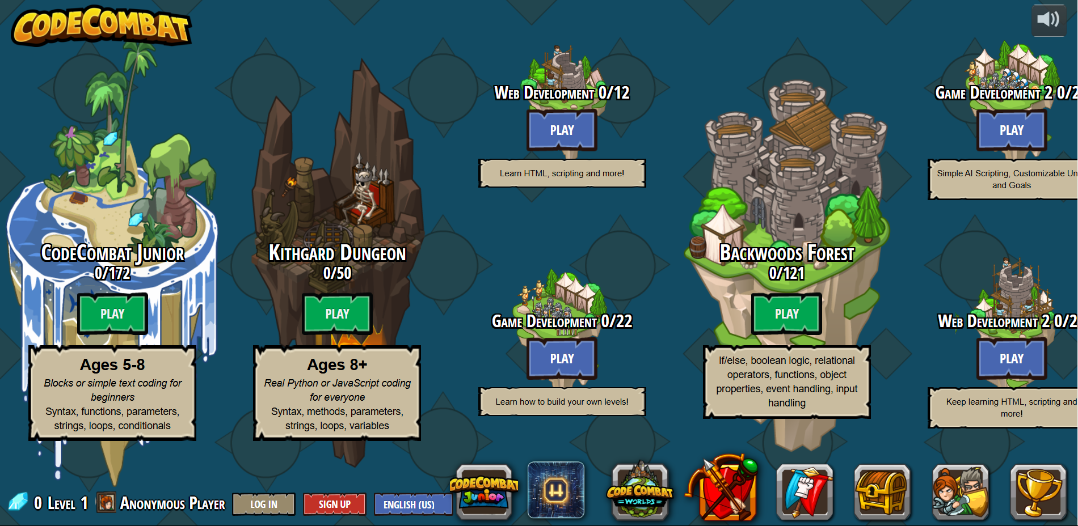
Figure 2.1: CodeCombat Interface

2.4.2. Roblox Education
​Roblox Education leverages the popular Roblox game development platform to teach computing and creative skills. This program allows students to create and publish their own games, providing hands-on experience in programming and game design. By combining education with an already familiar and engaging platform, Roblox Education enhances learning in a fun and collaborative environment.​
The game creation tools within Roblox Education empower learners to design, build, and share their projects, offering them full creative control. This process introduces programming concepts through Lua scripting, a language widely used in game development. Students gain a practical understanding of coding and its applications, bridging the gap between theory and practice.​
Roblox Education emphasizes collaboration, encouraging students to work on shared projects and engage with a larger community of creators. This collaborative approach fosters teamwork, communication, and problem-solving skills—essential competencies in the computing field. Through peer interactions, students also learn to critique and refine their work, enhancing their creativity and technical expertise.
The platform also offers career preparation opportunities by introducing students to real-world game development workflows and entrepreneurial skills. By creating and monetizing games, learners acquire knowledge about project management, user engagement, and revenue generation, providing a comprehensive view of the game development industry. These features make Roblox Education not just an educational tool but also a gateway to potential career pathways.​
In terms of adaptive testing capabilities, Roblox Education does not come with any built-in adaptive testing tools. Although the platform provides a dynamic setting for learning and game development, it is devoid of built-in features that modify the level of difficulty of the content according to each learner's performance. In order to include adaptive learning experiences into the Roblox environment, educators may need to create their own scripts or use third-party technologies. Because of this lack of inherent flexibility, customization mainly depends on the initiative and technical know-how of the teacher to modify experiences to fit the needs of various learners.
However, a potential limitation is the platform’s focus on game development, which might not address broader computing topics like algorithms or cybersecurity. Expanding its curriculum to include these areas could make Roblox Education a more versatile resource for computing education.

2.4.3. CodinGame
CodinGame is a unique platform that blends competitive programming with gamification, creating an engaging environment for learners to hone their coding skills. Users solve algorithmic problems by writing code that controls game elements, such as navigating a spaceship or optimizing processes in a simulated factory. The platform supports over 25 programming languages, catering to a diverse audience with varying skill levels.​
One of CodinGame’s most appealing features is its multiplayer challenges, where users engage in real-time coding battles with others. This competitive aspect fosters a sense of community and motivates participants to improve their skills. These challenges also encourage strategic thinking and adaptability, as players must develop efficient solutions under time constraints.​
The platform’s variety of supported languages ensures accessibility for learners and professionals alike. From Python and JavaScript to niche languages like Rust, CodinGame accommodates a wide range of programming preferences. This inclusivity allows users to practice their preferred languages while exploring new ones, broadening their technical expertise.​
CodinGame’s focus on problem-solving is another key strength. The platform offers diverse puzzles that challenge users to think logically and develop efficient algorithms. These tasks simulate real-world programming scenarios, helping learners build practical skills applicable to professional environments. The integration of coding into game mechanics further enhances the learning experience by making abstract concepts tangible and engaging.​
Despite its strengths, CodinGame may not cater well to complete beginners, as its challenges often require a basic understanding of programming. Incorporating more beginner-friendly tutorials could expand its accessibility. Additionally, CodinGame does not inherently include adaptive testing features that adjust the difficulty of challenges based on individual performance. While the platform offers a range of problems varying in complexity, the progression is generally linear and does not dynamically adapt to a user's skill level in real-time. Implementing adaptive learning mechanisms could further personalize the experience, ensuring that users are consistently challenged at an appropriate level. Nonetheless, CodinGame remains an excellent resource for intermediate to advanced learners aiming to refine their coding and problem-solving skills.
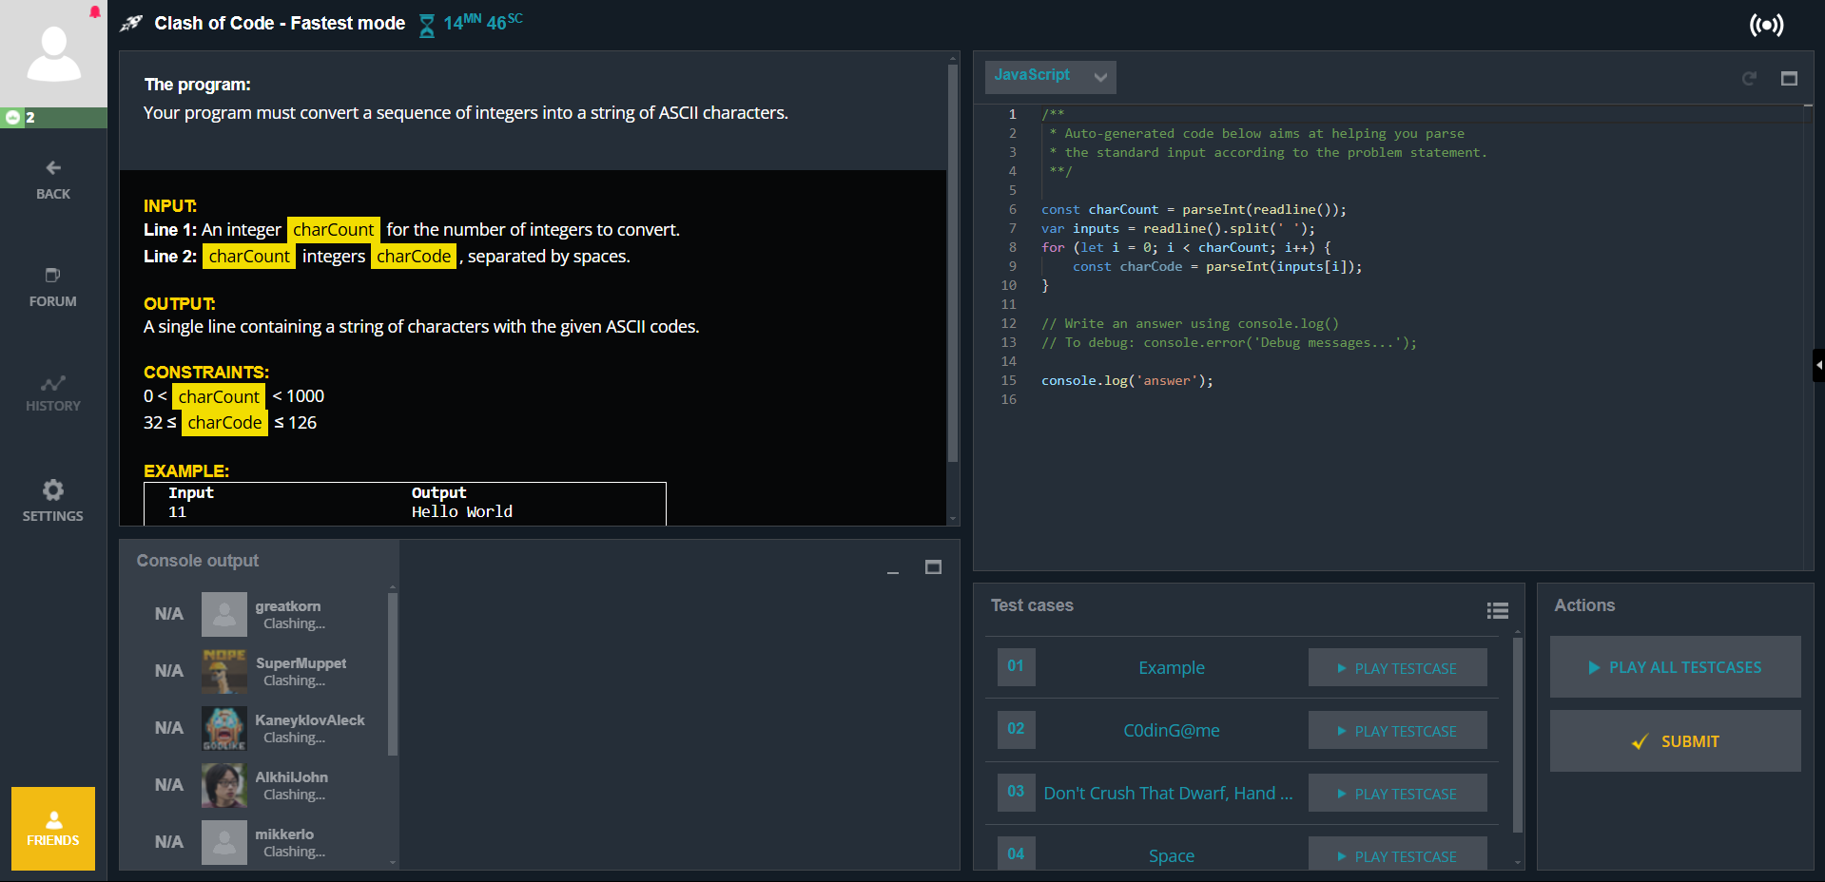
Figure 2.2: CodinGame Interface

2.4.4. Concerto Platform
The Concerto Platform, created by the University of Cambridge's Psychometrics Centre, is a noteworthy example of an existing system that uses Item Response Theory (IRT) to execute Computerized Adaptive Testing (CAT). A robust, open-source web-based framework called Concerto was created specifically for the development and implementation of adaptive tests. Concerto stands out due to its accessibility and versatility, as well as its use of IRT models, including the one-, two-, and three-parameter logistic models. The platform's developers believe that "online adaptive testing should be available to everyone," which is why it has no hidden license fees, set-up costs, or other restrictions. This makes it ideal for both short- and long-term assessment projects (Concerto Platform, 2024).
Technically speaking, Concerto combines the flexibility of HTML, the data security of MySQL databases, and the statistical power of the R programming language to produce a testing environment that is both responsive and adaptable. Together, these elements provide users with "unparalleled freedom and control" over the organization, reasoning, and display of their evaluations (Concerto Platform, 2024). Additionally, automated report production and score calculation are handled by built-in algorithms, making the test-taking and administration processes seamless. Because Concerto is web-based and modular, it can be tailored to many testing environments, ranging from corporate recruitment and research to education and healthcare. It also facilitates integration with bespoke user interfaces.
In summary, Concerto represents a highly practical and academically grounded CAT system that lowers barriers to entry while maintaining advanced psychometric capabilities. Its open-source nature and strong community support make it a valuable tool for researchers and practitioners interested in adaptive testing.

2.5. Challenges and Limitations of Existing Tools
Despite the potential of gamification, existing tools face several limitations:
- Focus on Introductory Topics: Platforms like CodeCombat primarily cater to beginners, neglecting the needs of advanced learners. For example, while these tools excel at introducing basic concepts, they often fail to provide the depth required for mastering complex topics such as advanced algorithms or system design. This gap leaves learners unprepared for real-world applications of computing knowledge.
- Limited Curriculum Alignment: Many tools prioritize engagement over alignment with formal educational standards (Gari et al., 2018). This misalignment reduces their effectiveness in supporting structured learning paths. Tools that fail to align with curricula may also overlook critical concepts, thereby impeding the holistic development of learners.
- Superficial Engagement: Entertainment often takes precedence over educational value, limiting the development of critical thinking skills (Chuang et al., 2024). This issue is compounded when tools rely excessively on gamified elements without integrating meaningful educational content. As a result, learners may find the experience enjoyable but fail to acquire deeper knowledge or skills.
- Scalability Issues: Existing platforms struggle to address the diverse needs of learners across varying expertise levels. For instance, while beginners benefit from basic gamified tasks, advanced learners often require complex and adaptive challenges to remain engaged. A lack of scalability hinders the ability to cater to this broad spectrum of needs, leaving many learners underserved.
- Technical Barriers in Open Tools: Despite being robust and open-source, platforms like as Concerto frequently necessitate a high level of technical competence for setup and modification. Despite being advertised as user-friendly, its implementation requires setting up servers, databases, and statistical tools like R, which might be difficult for practitioners or instructors who are not programmers.

These challenges underscore the necessity for a gamified learning platform that integrates curriculum-aligned content with engaging, adaptive, and meaningful game mechanics. By addressing these gaps, the proposed platform aims to support deep and structured learning, particularly in advanced computing topics. Furthermore, incorporating advanced features such as dynamic question adaptation, comprehensive progress tracking, and personalized feedback can transform the learning experience into one that is not only engaging but also educationally robust. The focus on scalability and curriculum alignment ensures that the platform remains relevant across a wide range of educational contexts, making it a versatile tool for learners at all levels.

2.6. Summary and Conclusion
In order to improve programming education, especially through gamification and adaptive testing, this chapter has offered a comprehensive assessment of the pertinent ideas, practices, and systems now in use. The main focus was on how gamified learning environments may increase student engagement and comprehension while addressing the difficulties students encounter when learning programming fundamentals like data structures. We looked at the functions of gamification, item response theory (IRT), and computerized adaptive testing (CAT), all of which are essential to developing more individualized, successful learning experiences.
The evaluation of current platforms, including Roblox Education, Lightbot, CodinGame, and CodeCombat, demonstrated the advancements made in incorporating gamified learning environments into the teaching of programming. Lightbot is an interactive platform that uses puzzles to teach programming topics, assisting students in comprehending algorithms and logic. A more competitive method is provided by CodinGame, which pushes students to solve coding problems that assess their knowledge of several programming languages. By giving kids the opportunity to design and build their own games, Roblox Education provides a hands-on learning experience while introducing game creation to younger audiences. Through the use of a game-like interface, CodeCombat exposes students to more sophisticated ideas like data structures by having them write code to move characters through difficulties.
None of these methods completely incorporates adaptive testing to provide a customized learning path, despite the fact that each offers advantages. All of these systems have gamified components, but they don't offer adaptive feedback that customizes the learning experience or dynamically adapt to a learner's skill level in real time. This lack of integration draws attention to a significant weakness in the current environment: a system that integrates adaptive testing and gamification is required to improve programming education, particularly when teaching intricate subjects like data structures.
To sum up, this chapter has offered a thorough analysis of the mechanisms in place for teaching programming and highlighted the shortcomings in fusing dynamic, individualized evaluation with interesting, game-based learning. The proposed study intends to close these gaps by creating a system that combines adaptive testing and gamification, providing a more individualized learning environment that can successfully assist students in grasping programming fundamentals like data structures.

CHAPTER THREE
RESEARCH METHODOLOGY

3.1. Preamble
Research design for improving learners' comprehension of programming through the process of using CAT-IRT to optimize test design for concepts of the data structure is outlined in detail in this chapter. It covers the design of the study, the proposed model, the tools and methodologies utilized, and the criteria for measurement of effectiveness. The process of the methodological design has been organized around iterative system design and experimental evaluation.
The five overall goals informing the methodology are: tuning an already existing CAT-IRT model for adaptive testing, developing and deploying the adaptive testing platform, incorporating gamification components, assessing the platform versus standard testing approaches, and examining its effect on the performance of learners. Each goal has particular techniques and tools informing the development and evaluation of the platform.

3.2. Research Design
To design a gamified adaptive examination platform to improve the understanding of data structure concepts among the learners, this study adopts a two-phase design strategy integrating an exploratory with an application technique. To enhance performance and interest, the platform utilizes gamification elements in conjunction with Computerized Adaptive Testing (CAT) and Item Response Theory (IRT).
The research follows a two-phase approach:
- Phase 1: Exploratory Design
Evaluative approach is employed in the first step to test the flexibility and performance of a better CAT-IRT model. A current adaptive test engine is refined in this step by collecting a dataset of labeled test questions with mappings to IRT values for difficulty, discrimination, and guessing. The primary aim in this step is to verify the model's correctness and consistency in ability prediction of the student and question selection.

- Phase 2: Applied Design
In the second step, the validated CAT-IRT model is converted to a fully web-adaptive test platform with gamification components. System design, architecture, UI coding, adaptive test logic implementation, and gamification aspects, including leaderboards, badges, and incentives for progress, are all part of this step.

3.2.1. The Proposed Model
This section discusses the design and workflow of the proposed system, incorporating interactive game-like features along with adaptive assessment based on CAT-IRT to enhance learner interest and comprehension of the principles of programming.
- Theoretical Background
The 3-parameter logistic (3PL) model, a component of Item Response Theory models, serves as the backbone of the adaptive test engine. Difficulty, or the difficulty of an item; discrimination, or the discriminative power of a question to distinguish between high- and low-ability students; and guessing, or the chance of getting a question right, are taken into account by the 3PL model.
Through the adaptive question selection mechanism, these factors allow the system to measure the ability of a learner in real time and dynamically change the difficulty of the test.
- Reason for Model Selection
Because of its ability to maximize measurement efficiency, eliminate test fatigue, and make the assessment personalized, CAT-IRT was chosen. The approach provides an enhanced understanding of each learner's level of mastery via adaptation of the question difficulty to the learner's expected capability. Motivation of the learner, a very significant component of coding education, is addressed by incorporating gamification.

Model Framework / Workflow
- Input and Dataset Curation
- The system employs a pre-curated collection of multiple-choice coding questions linked with IRT parameters.
- Questions are structured by subject, complexity, and concept to provide thorough coverage of the subject matter of data structures.
- Fine-tuning CAT-IRT Model
- The model is then fine-tuned on the annotated data using machine learning libraries (in this case, PyTorch or TensorFlow).
- Simulated learner responses are constructed to confirm adaptive behavior.
- The model learns to predict student capability and choose the next most helpful question given the answers previously seen.
- System Design and Development
- A web platform is built utilizing Next.js for the user interface and backend APIs with TypeScript.
- RESTful APIs link the frontend to the CAT engine to retrieve the next best question in real time.
- Gamification Integration
- The platform has badges, points and leaderboards.
- Badges are gotten from accomplishing milestones (e.g., completing a certain number of quizzes).
- Feedback is gamified to encourage learners and minimize test anxiety.
- User Testing and Feedback Loop
- Students engage with the platform through test sessions.
- Their answers are recorded, and performance and engagement metrics are gathered.
- The system applies these metrics to improve upcoming test sessions and provide a better user experience.

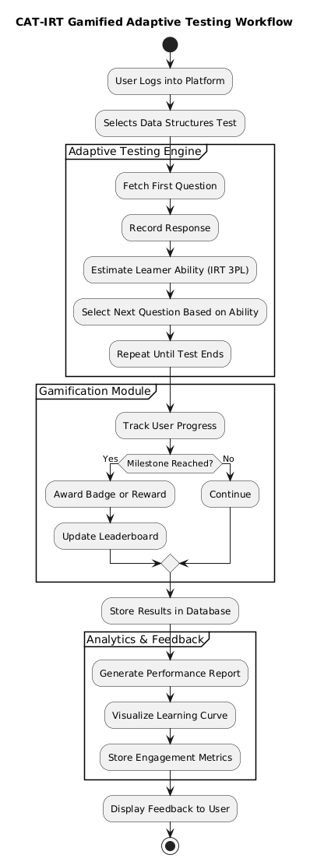

3.3. Methodology for Objective One - Refining the CAT-IRT Model
The aim is to calibrate a pre-existing CAT-IRT model to create an accurate and adaptive test to gauge learners' grasp of program concepts, the subject in question being data structures. The test questions could be dynamically altered in accordance with each learner's performance and capability with the aid of the calibration.

3.3.1. Data Collection
A carefully selected dataset of multiple-choice questions on basic data structure concepts was developed. The 3-Parameter Logistic (3PL) Item Response Theory (IRT) model was employed to attribute IRT parameters difficulty, discrimination, and guessing to every question. These IRT parameters are useful while estimating the probability that a student would answer a question correctly as a function of his/her competence.

3.3.2. Pre-processing
Python was utilized to standardize and organize the dataset properly to prepare it for model training. Numerical scales were employed to transform categorical values such as "difficulty" and "discrimination." To represent various skill levels, simulated learner replies were generated. The adaptive engine was then trained on a student-question corpus developed from the simulated exchanges.

3.3.3. Model Fine-tuning
The annotated data was utilized to refine the CAT-IRT model. Depending on the model variant, PyTorch and TensorFlow frameworks were utilized to execute the training process. By embedding the 3PL IRT mechanics directly in its train logic, the model could employ the real-time ability estimate to dynamically select questions during the evaluation. Employing the validation splits, hyperparameter tuning was performed to maximize the variables of learning rate, batch size, and the number of epochs for training. If any contextual adaptation and sequence encoding were required by the assessment system, Hugging Face Transformers were an available choice.

3.3.4. Evaluation
Following the fine-tuning process, simulated test situations were employed to evaluate the performance of the model. The accuracy of the ability estimate was measured via metrics such as Root Mean Square Error (RMSE), whereas adaptive performance was measured via some additional metrics such as question selection efficiency as well as convergence rate. The benefits of adaptivity in the context of test time reduction and improved learner targeting were estimated with the support of comparative testing with fixed-form tests.

3.4. Methodology for Objective Two - Design and Implementation of an Adaptive Testing Platform
The goal would is to create and implement an adaptive web-based test platform fully compatible with the optimized CAT-IRT model. The platform would be the central interface through which learners would take adaptive tests.

3.4.1. Requirements Gathering
- Functional Requirements:
The platform ought to have core adaptive testing functionality, such as user authentication, test session initialization, CAT logic-driven question delivery, and response tracking. It should support learners taking a custom sequence of questions whose difficulty level changes accordingly based on their performance. The platform ought to allow administrators to upload annotated test items, keep an eye on the progress of the students, and see performance analytics. The system should expose APIs to interface with the CAT-IRT engine to select questions and estimate ability.
- Non-functional Requirements:
The platform should be scalable to accommodate many users at once, responsive to provide real-time interaction, and secure in handling student information and test results. It should maintain low latency during the time between submitting an answer and the presentation of the next question to keep the adaptive experience intact. The UI should also be intuitive and interactive to guarantee user satisfaction and simplicity in navigation.

3.4.2. System Design
- Front-end Design:
Next.js is utilized in the development of a responsive and dynamic web interface. The interface has specific views for the learners (e.g., test dashboard, active test screen, result feedback) and administrators (e.g., question bank management, analytics dashboard). Wireframes and mock-ups were made during the design phase to establish user flows and visual hierarchies.

- Back-end Design:
TypeScript is utilized to create type-safe RESTful APIs to act as the interface between the front-end and the CAT-IRT model. These APIs manage session handling, question requests, submission of answers, and calculation of results. The backend framework has been developed using modular endpoints to make the CAT engine easier to integrate and test.

3.4.3. Implementation
- Front-end Development:
The user interface was built utilizing the Next.js framework. Focus was given to a clean and distraction-free test interface, adaptive navigation, progress tracking, and dynamically loaded questions based upon the response from the APIs. Principles of accessibility and responsive design were utilized to support multi-browser, multi-platform compatibility.
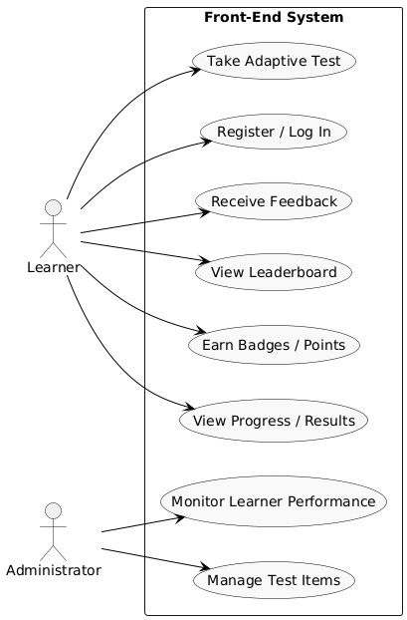

- Back-end Development:
The backend was developed using TypeScript and Node.js in accordance with RESTful design. Each of the endpoints talks to the CAT-IRT engine running as a microservice or local module, calling functions to choose the next question based on real-time estimation of the learner's ability. User and test information are stored in a secure database, and response histories are recorded for later analysis.
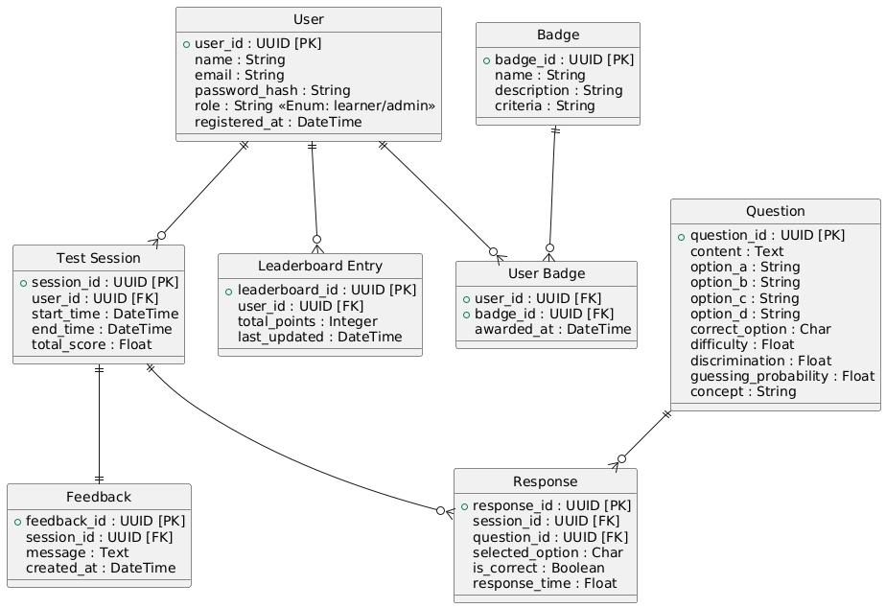
- Integration:
The CAT-IRT capability is built into the platform as a central feature. The system updates and retrieves the learner's measured ability after every question via API calls and provides the next question accordingly. This enables the test to be adaptive in real-time, providing each learner with a personalized test experience. Logs and analytics are retained for real-time tracking and for performance evaluation in the future.

3.5. Methodology for Objective Three - Development and Integration of Gamification Elements
The third goal focuses on improving the learner experience through the creation and incorporation of gamification components on the adaptive testing platform. The goal is to create a heightened engagement, motivation, and ongoing participation by tapping into game mechanics including points, badges, and leaderboards. These are aimed at augmenting the adaptive test flow and not compromising the core learning process.

3.5.1. Requirements Gathering
Successful engagement mechanisms were derived from an examination of available gamified learning platforms. Educators and subject experts were consulted to establish what motivational stimuli would be best suited for learners learning about programming concepts. Primary requirements that surfaced were the application of achievement rewards, informative progress indicators, and healthy competition support mechanisms, including leaderboards.

3.5.2. System Design
The system was developed with a modular framework to allow seamless gamification to be incorporated without interrupting the adaptive test flow. The front-end was organized to contain special components in the form of a gamified dashboard, and visual indicators for rewards at the end of tests in the form of points or achievements. All these components were developed with user engagement in mind to make the visual feedback rewarding yet not distracting.
A gamification logic layer was coded exclusively on the back-end. This module follows user interaction and initiates reward mechanisms on the basis of pre-set criteria like question correctness, difficulty, and frequency of participation.

3.5.3. Implementation
The system rewards learners in real time for their activities, giving points and initiating visual feedback for right answers or milestones. Badges are awarded to the learners for learning milestones such as first time taking a quiz on the platform, completing twenty quizzes on the platform and so on. A leaderboard is built dynamically with stored user information to display users with the highest points and create a healthy competitive spirit among the learners

3.6. Methodology for Objective Four - Model Evaluation
The evaluation of the adaptive CAT-IRT model focused on assessing its accuracy and effectiveness in predicting learner responses and selecting appropriate test items based on learner ability. The study employed a quantitative evaluation approach, analyzing model output and prediction accuracy through system-level metrics.

3.6.1. Data Collection and Evaluation Metrics
The following metrics were used to evaluate model performance:
- Accuracy: Measures the proportion of correctly predicted learner responses.
- Mean Reciprocal Rank (MRR): Evaluates how well the model ranks questions according to learner ability.
- Normalized Discounted Cumulative Gain (nDCG): Assesses the relevance of question difficulty ordering in the adaptive testing context.
- Root Mean Square Error (RMSE): Quantifies the difference between predicted and actual learner response probabilities or ability estimates.
Model logs containing predicted responses, question difficulty selections, and estimated ability scores over time were analyzed to validate the precision and adaptivity of the model.

3.6.2. Evaluation Tools and Techniques
Python was used for all data processing and analysis tasks. Libraries such as Pandas and NumPy facilitated data manipulation, while Matplotlib and Seaborn were used for visualization. Custom scripts calculated evaluation metrics to ensure accurate performance assessment of the CAT-IRT model

CHAPTER 4
SYSTEM IMPLEMENTATION AND EVALUATION

4.1. Preamble
This chapter gives an elaborate description of the approach employed to design the adaptive gamified test platform based on the CAT-IRT model developed. It elaborates on the system requirements, the tools employed for development, the strategy of implementation, and the steps taken to measure platform performance and user interaction.

4.2. System Requirements
This section explains the conditions in which the system was developed and expected to operate smoothly. It comprises all the software and hardware necessary to install and execute the adaptive test platform with ease.

4.2.1. Hardware Requirements
The major hardware requirements for the implementation of the system is given in the table below.
S/N | REQUIREMENT | HARDWARE
1. | Processor | Intel core i5 or higher/ Apple M1 chip
2. | Primary Memory | 16 GB RAM or higher
3. | Architecture | 64Bit (X64) for windows / ARM X64
4. | Secondary Storage | 32GB HDD or higher

4.2.2. Software Requirements
A number of software pieces must be used to design, implement, and execute the adaptive gamified test system. The system takes advantage of a mix of client-side, server-side, and model-related technology to deliver a smart and interactive test experience. The primary software requirements and their respective functions are documented in Table 4.2.

S/N | REQUIREMENT | SOFTWARE
1. | Operating System | Mac OS: v11.0.0 or higher  Windows: 10 or higher  Linux: Ubuntu
2. | Programming Language | Python 3, TypeScript
3. | Database Management System | NodeJs(platform backend), Postgress(Model local backend)
4. | Development Tool | VS Code, PyCharm
5. | Frameworks | Next.js (web platform), PyTorch/TensorFlow (model training)
6. | Model Deployment | Github and Render
7. | Libraries
  Pandas, numpy, torch, scipy, Flask, pymongo, gunicorn

4.3. Implementation Tools
I made use of the following core tools to build the intelligent adaptive testing platform. Their support for both frontend and backend, along with system architecture compliance, were the key factors to consider while selecting them. The following lists the most significant ones (the entire list can be seen in Table 4.2).

4.3.1. Python 3
Python was employed to develop and refine the models and create the backend functionality of the adaptive testing system. It was easy to test and implement because of the large collection of machine learning and data science packages in its ecosystem.

4.3.2. TypeScript
I utilized TypeScript exclusively during the development of the frontend and API. Generally, the web app was more reliable and easier to debug as a result of its static typing.

4.3.3. Next.js
My go-to framework for developing the user interface of the adaptive test platform was Next.js. It performed exceptionally and supported server-side rendering, both of which were useful for responsive interfaces.

4.3.4. Node.js
The backend of the online platform was powered by Node.js. It handled routing, session handling, APIs, and a significant amount of platform logic.

4.3.5. MongoDB
MongoDB served as the database. It was used during model tests and evaluations to store test results, learner performance and progress information, and test logs.

4.3.6. Visual Studio Code (VS Code)
Visual Studio Code was my primary code editor for front-end development. It was very light-weight and useful to debug with when coding in TypeScript and Node.js.

4.3.7. PyCharm
I used PyCharm for Python development and model training. PyCharm is great at handling virtual environments, debugging, and large-scale codebases.

4.3.8. PyTorch
I utilized PyTorch as my core tool for the adaptive test model development and model optimization. PyTorch's ability to process graphs dynamically and flexibility proved convenient for experimenting with the model.

4.3.9. TensorFlow
TensorFlow compatibility and deployment were specifically examined. It provided efficient optimization features and was considered for scaling.

4.3.10. GitHub
GitHub was used to control versions and collaborate collaboratively. It played a significant role in handling backups, updates, and tracking the repositories.

4.3.11. Render
The backend service and the API endpoints were deployed via Render. It simplified deployment without requiring a complicated infrastructure setup.

4.3.12. Libraries
The creation of the API called for the use of a number of Python packages consisting of pandas, numpy, torch, scipy, and flask, pymongo and Gunicorn were utilized to deploy the app across the test rounds.

4.4. Development Methodology
The approach to development employed in this project was the Iterative and Incremental Development (IID) model. This was the best model to employ since it enabled me to develop the adaptive testing system in small functional pieces, each iteration adding new improvements, solving past problems, and addressing feedback.
I started the project with a top-down design of both the test model and web platform. As I went along, I made continual refinement on the different components particularly during the integration of the CAT-IRT model, adaptive logic, and gamification features. There were a few places where I had to redo question selection logic, user flow experiences, and the handling of model predictions based on live test results.
For instance, while working on the gamification module, I had to tweak the assignment of points and badges based on the difficulty of the test taken. Likewise, while refining the model, I iteratively experimented with various parameter configurations and handling of the data until it was optimal.
The IID approach served the project well because it allowed me to test and refine every iteration of the system in a rapid manner. It also enabled easier isolation of bugs, performance tuning, and scaling of features incrementally while keeping the platform functional and testable at each point.

4.5. Evaluation of the System
The adaptive test model proposed was tested to see how effective it was in the selection of question difficulty and estimation of learner ability. The process of testing involved making use of common ranking and classification metrics that are used in information retrieval and adaptive learning situations.
The performance of the model was measured using the following metrics:
  - Accuracy: It indicates the rate at which the model predicted the learner's response accurately.
  - Mean Reciprocal Rank (MRR): Assess how soon in the ranking the best fitting question (by ability match) occurs.
  - Normalized Discounted Cumulative Gain (nDCG): It evaluates the performance of the model in ranking questions by relevance (difficulty matching with the ability of the student).
  - Root Mean Square Error (RMSE): Represents the error in learner ability or response probability prediction.
These were calculated after the model was tested on simulated student interaction data and actual question parameters derived from Item Response Theory (IRT).

4.5.1. Evaluation Results and Discussions
Below are the evaluation results of the fine-tuned adaptive testing model:
S/N | Metric Test | SCORE(proposed model)
1 | Accuracy | 0.6645
2 | MRR | 0.1000
3 | nDCG | 1.000
4 | RMSE | 1.3275

The following describes the evaluation metrics based on the model evaluation results:
- Accuracy (0.6645):
This indicates the model accurately predicted the learner would answer a question right in about 66.5% of the test cases. This indicates a level of moderate predictive accuracy, where the system can distinguish overall between right and wrong answers but has potential to do better.
- Mean Reciprocal Rank (MRR: 0.1000):
A relatively low MRR score indicates the model tends to choose questions with the best fit later in the sequence over earlier. Though the system is picking the right questions, it might better rank and prioritize the most apposite items initially.

- Normalized Discounted Cumulative Gain (nDCG: 1.0000):
A perfect score on the right represents the model doing a great job at ranking questions by relevance to the learner's assumed ability. This verifies the finding that even when the most favourable questions are perhaps not available first (since MRR would indicate), the overall ordering is optimally placed in terms of difficulty matching.
- Ability RMSE (1.3275):
This indicates the overall error in estimating learner capability. A figure of ~1.33 indicates the system to be estimating capability in the right ballpark, but with some deviation between predicted and observed values. This could be enhanced with further fine-tuning of the IRT parameters or adaptive choice logic.
- Probability RMSE (0.2140):
This metric gauge the predictive accuracy in terms of the error in response probabilities. A measure of 0.2140 reflects good predictive precision, which indicates the model’s confidence in a learner answering a question correctly or incorrectly being reasonably accurate.
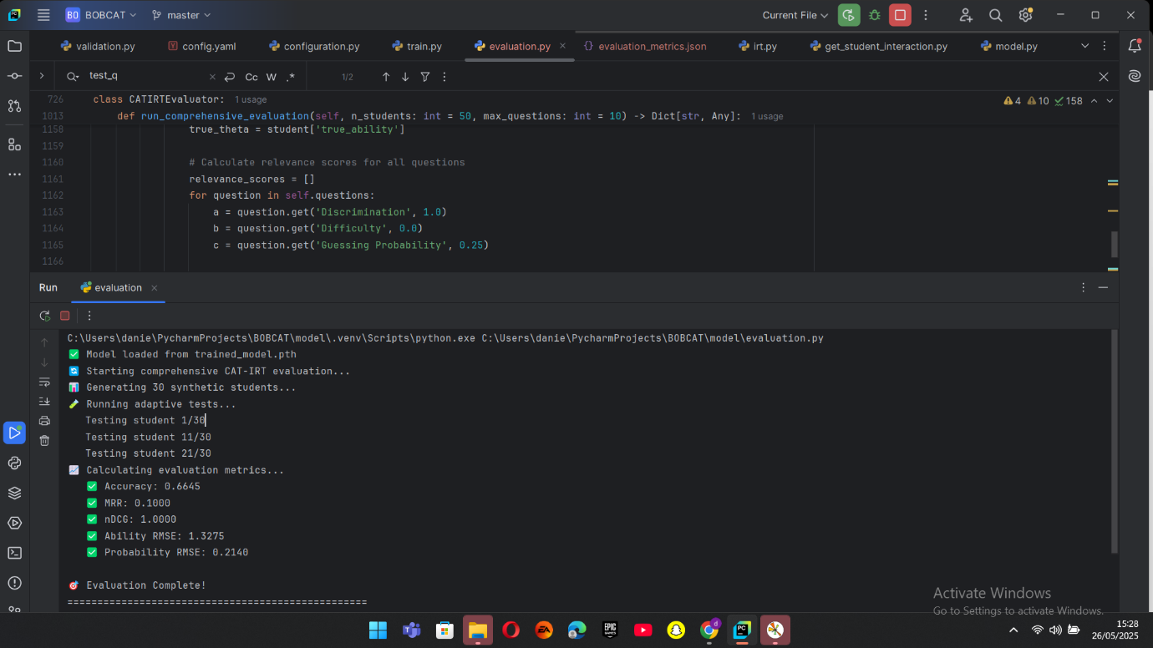
Figure 1.8 Model Evaluation Results

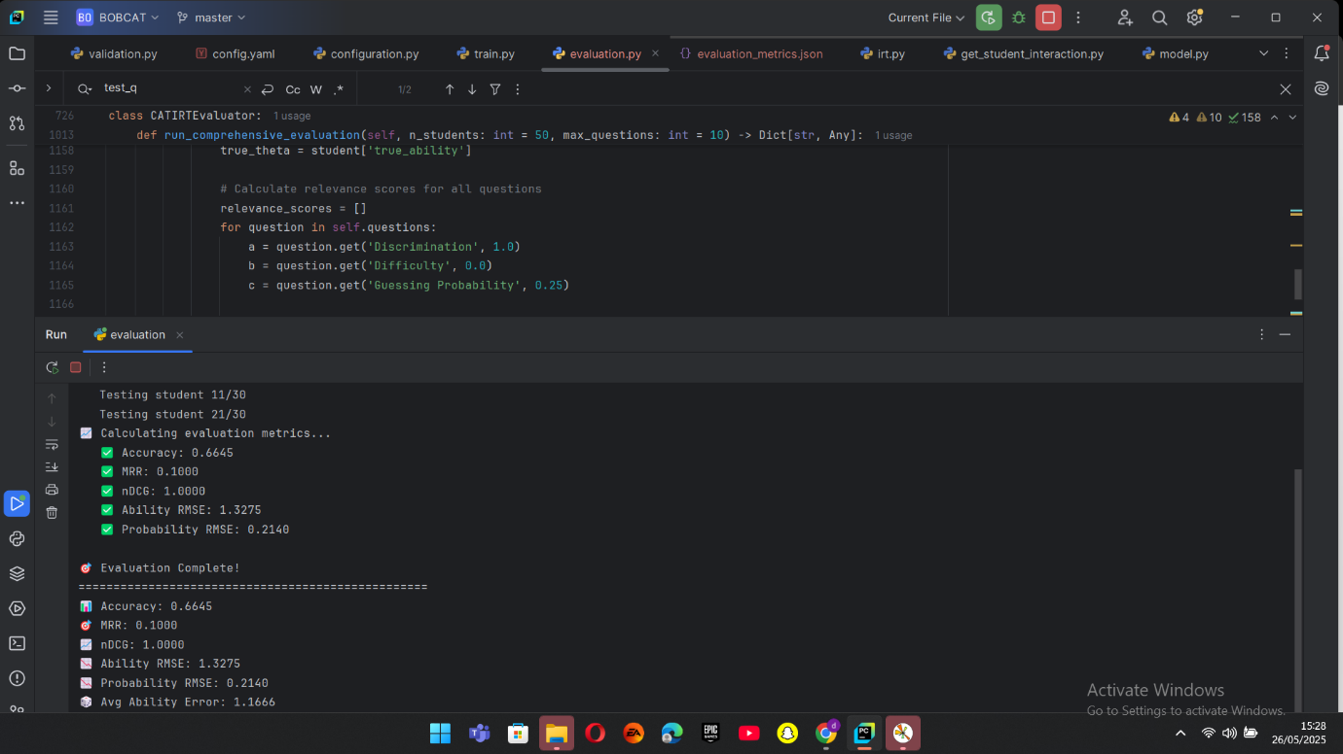
Figure 1.8 Model Evaluation Results

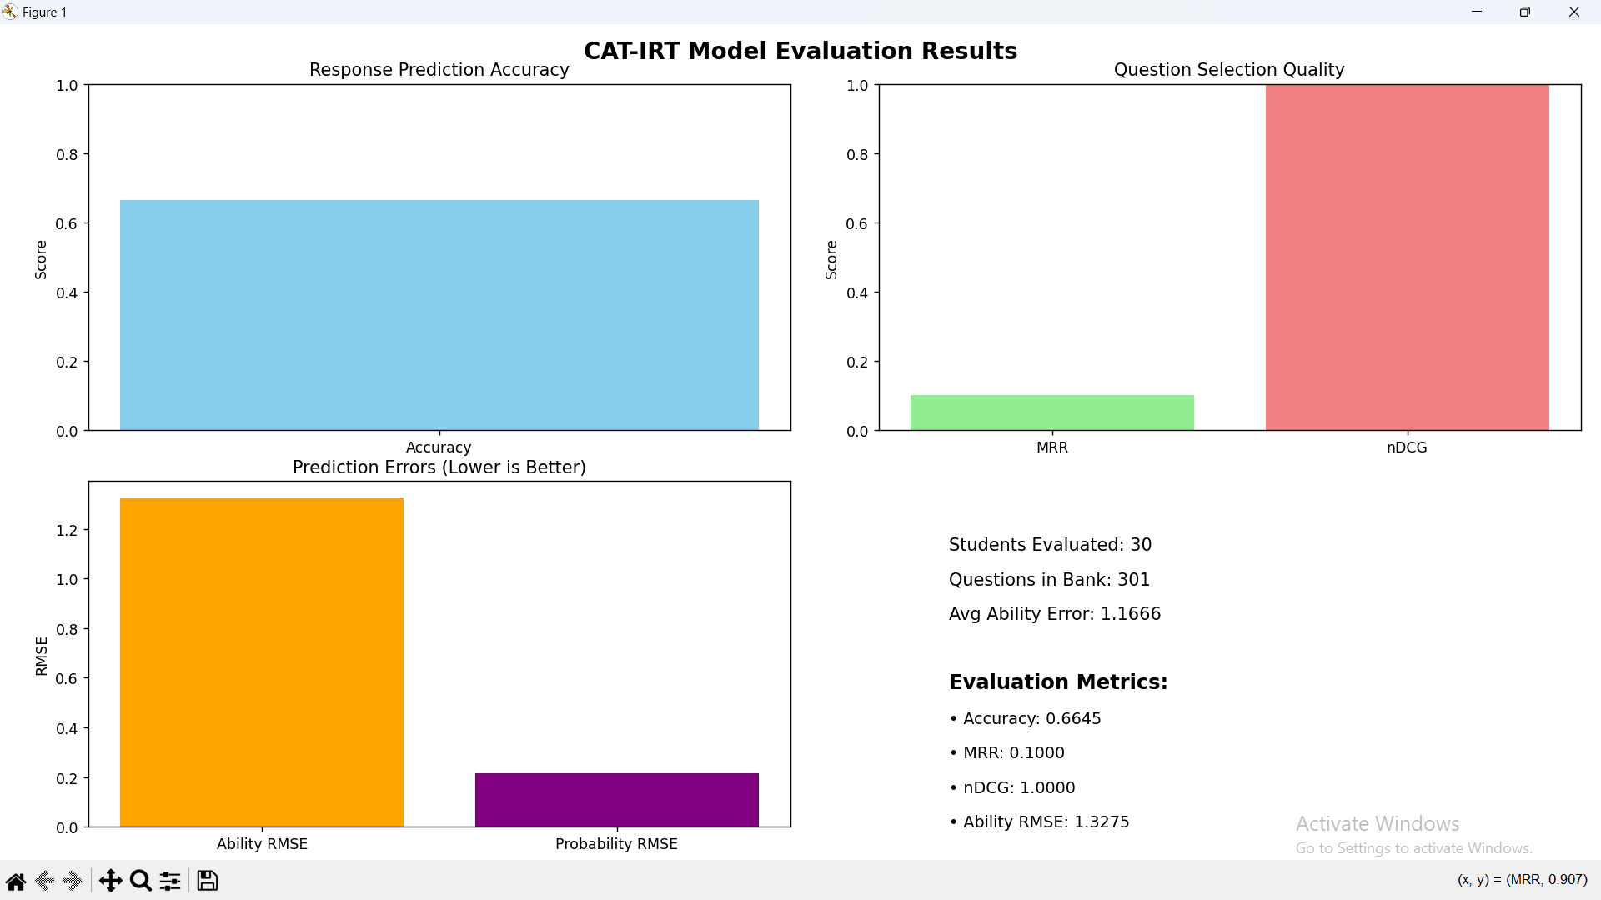
Figure 1.8 Model Evaluation Results

4.6. Program Modules and Interfaces

4.6.1. Login/Sign Up Interface
This page is where the user gets to sign up and sign into the system using their email and password.
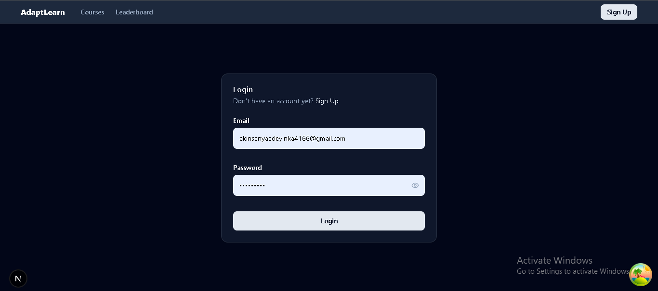

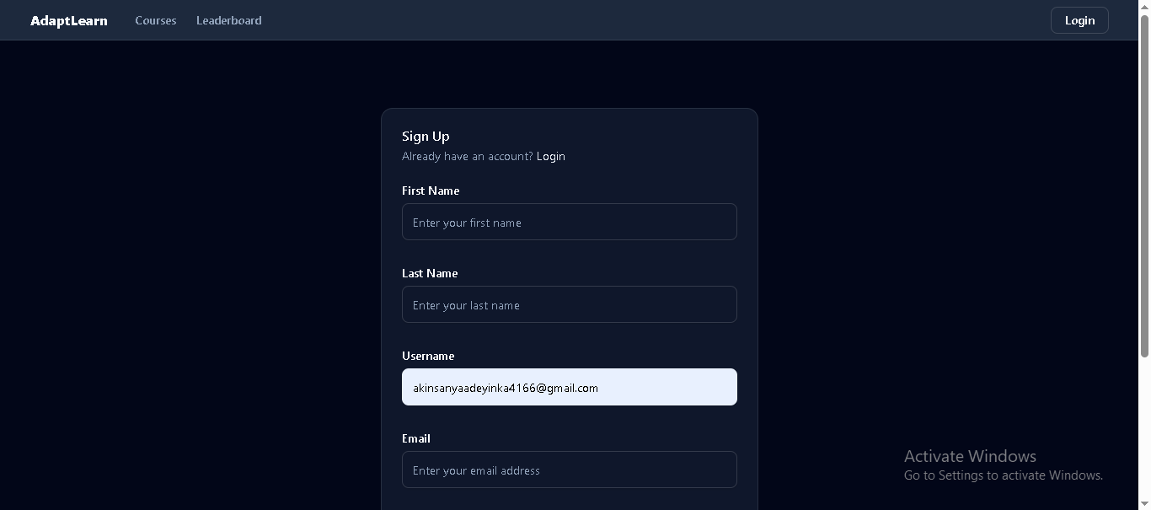

4.6.2. The Web Application Features:
These pages are where the user can interact with the web application by viewing topics, taking quizzes, earning points and badges, viewing leader board, etc.

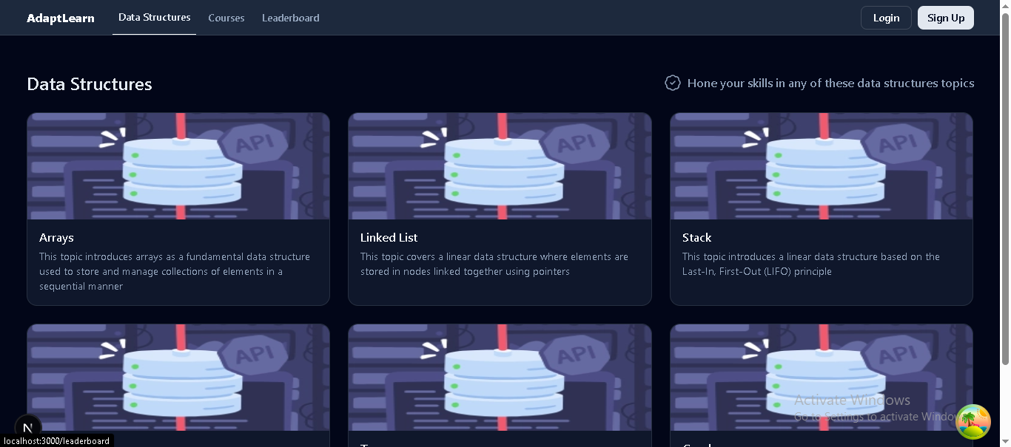
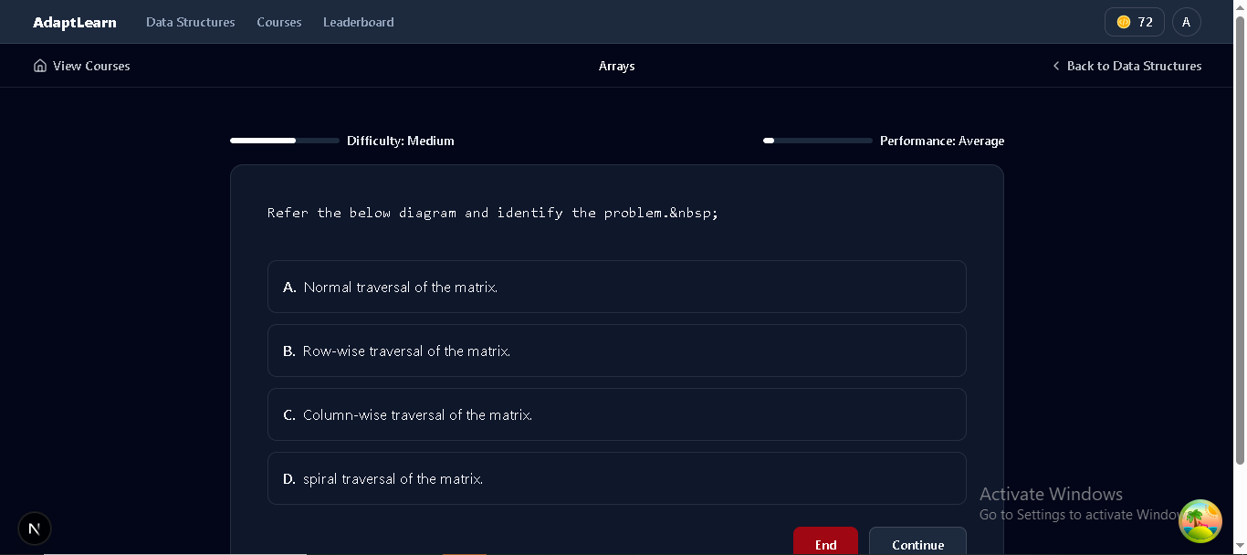

4.6.3. The Model Deployment (Render and GitHub):
This is where the CAT-IRT model was deployed to. It accessed the files from the GitHub repository the model was pushed to, and runs the model remotely so that it can be accessed in the app using API calls.
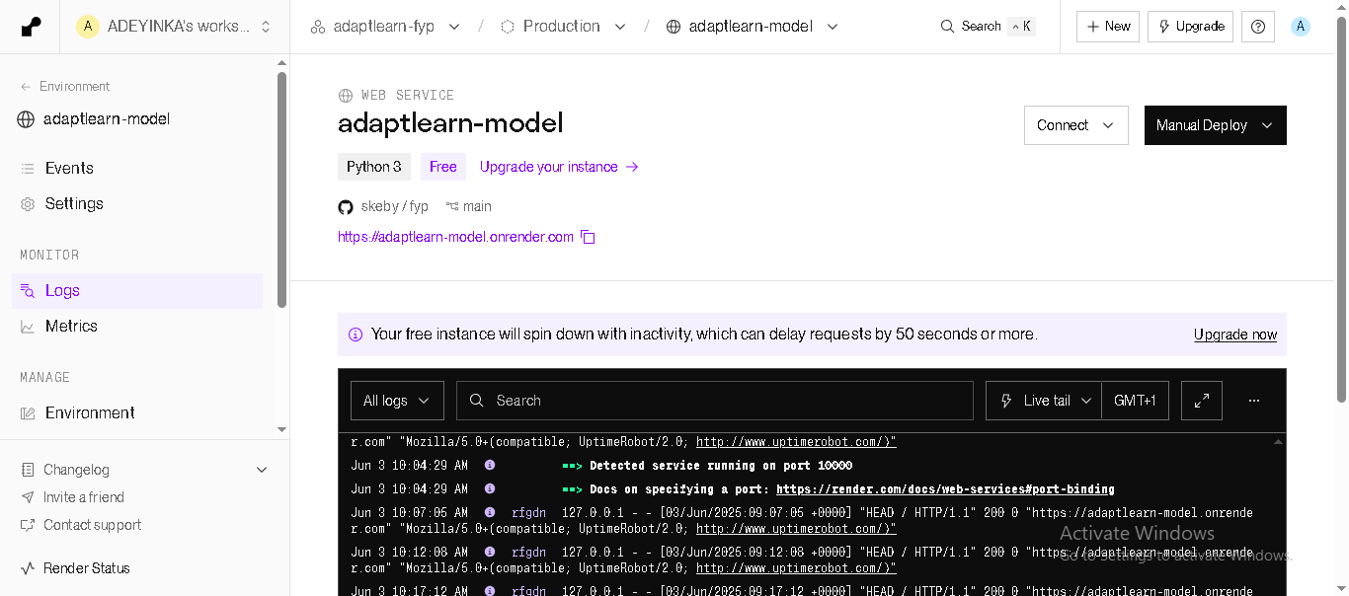

4.6.4. The MongoDB Database Interface:
This is the MongoDB interface where user details are stored, courses, and other application data are stored.
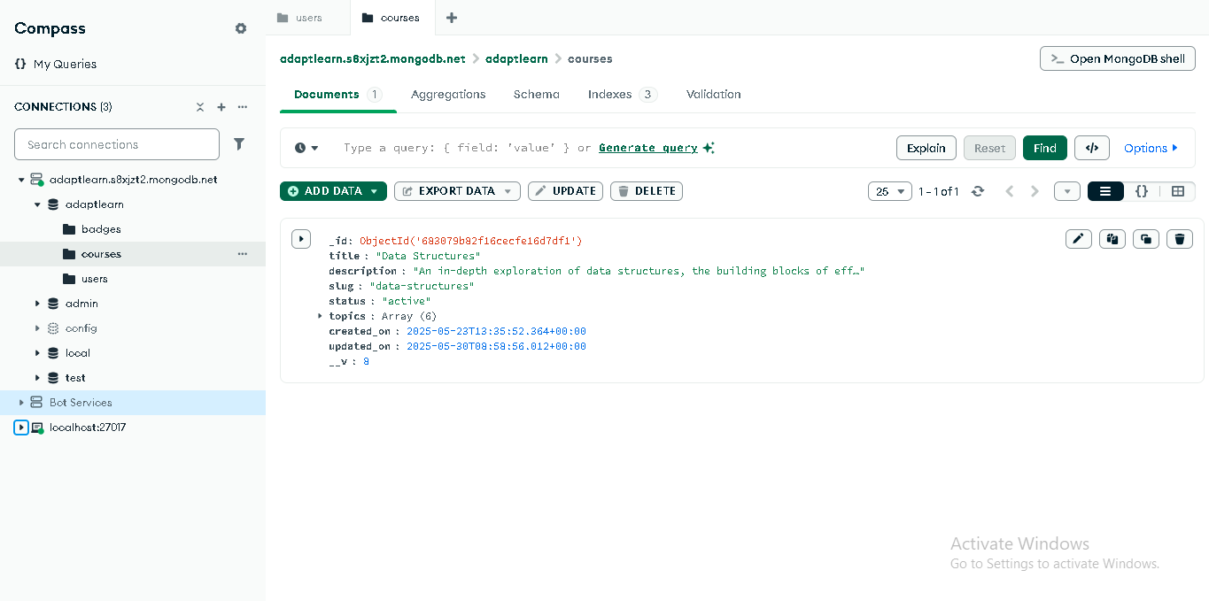

4.7. Exploratory Data Analysis (EDA) of the Dataset
Exploratory Data Analysis (EDA) was conducted on the simulated interaction data to understand the properties and structure of the data used for the training and evaluation of the CAT-IRT based adaptive test model.

4.7.1. Dataset Overview
Responses from simulated learners to a sequence of multiple-choice questions with IRT parameters form the dataset. Each row representing an independent learner-question interaction includes the following fields: Student ID, Question ID, Correct (0 or 1), Difficulty (continuous scale, typically 0 to 1), Discrimination (continuous scale), Guessing Probability (continuous or categorical), and (categorical topic tag).

4.7.2. Key Observations
The following are some key observations gotten from the exploratory data analysis:
- Question Distribution:
With question IDs from 1 to 301, the pool comprises 301 different questions. These questions represent a substantial question bank for adaptive testing since the student answers are scattered among them.
- Student Coverage:
There are a total of 15,000 interaction records with 500 unique students (Student IDs 0 to 499) answering a series of questions. This gives a good amount of student-question interaction data for model training.
- Difficulty Levels:
With a roughly 1.5 mean, the difficulty values range from about 0.5 to 2.5. The fairly evenly distributed difficulty allows for adaptive testing across easy to hard questions.
- Discrimination Values:
To discriminate among various levels of learners, discrimination values also varies between 0.5 and 2.5 roughly, showing a range of questions with low to high discrimination.

- Correct Response Ratio:
The correct response ratio is the proportion of total responses that were answered correctly in the dataset. The value was calculated as:

$$Correct response ratio= \frac{Number of Correct Responses}{Total Responses}= \frac{5600}{15000}= ≈0.375$$

- Guessing Parameter:
A realistic low probability of guessing consistent with standard 3PL IRT assumptions is embodied in the guessing probabilities, which are between 0.20 and 0.30 with a mean of approximately 0.25.
- Concept Coverage:
Six distinct concepts (arrays, linked lists, stacks, queues, trees, and graphs) are addressed at various frequencies throughout the dataset, allowing measurement of student performance across a range of subject themes.

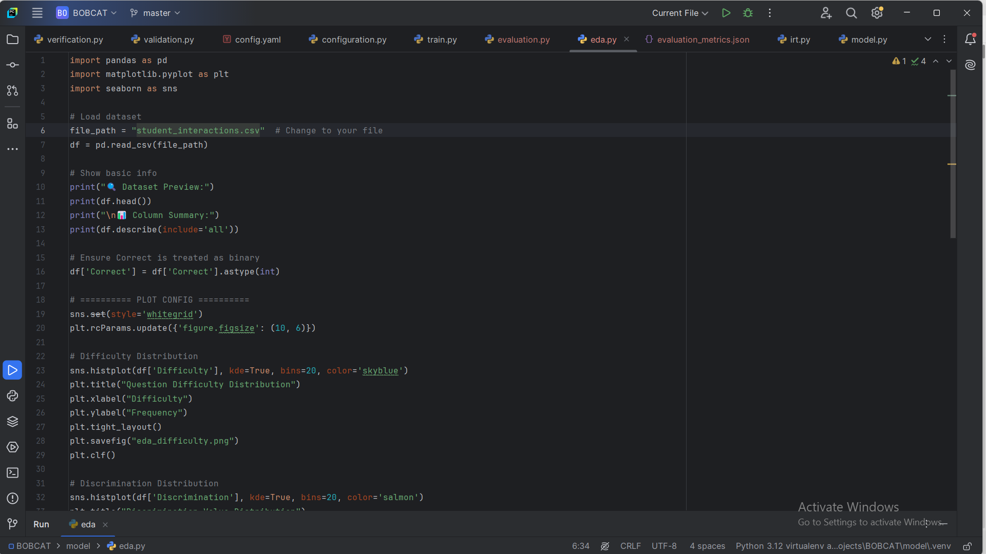
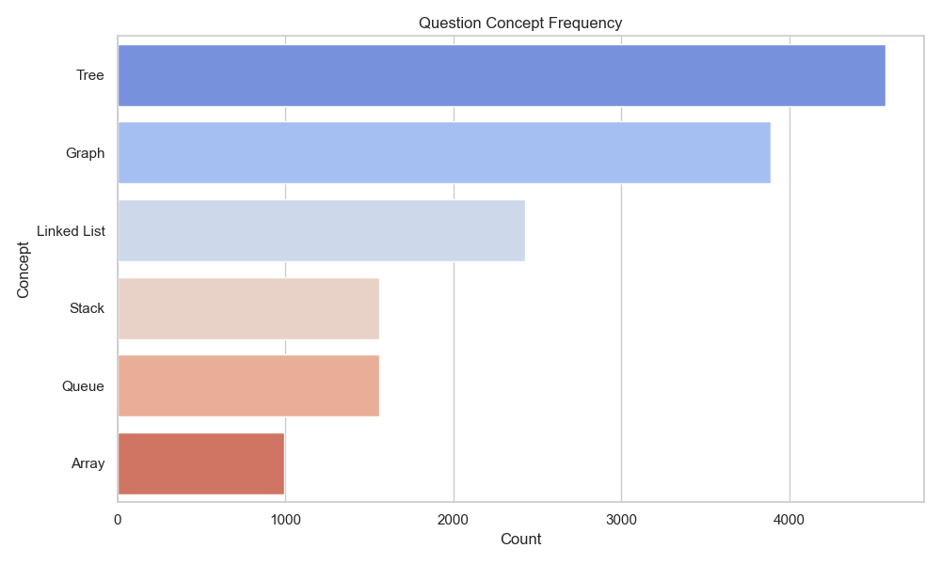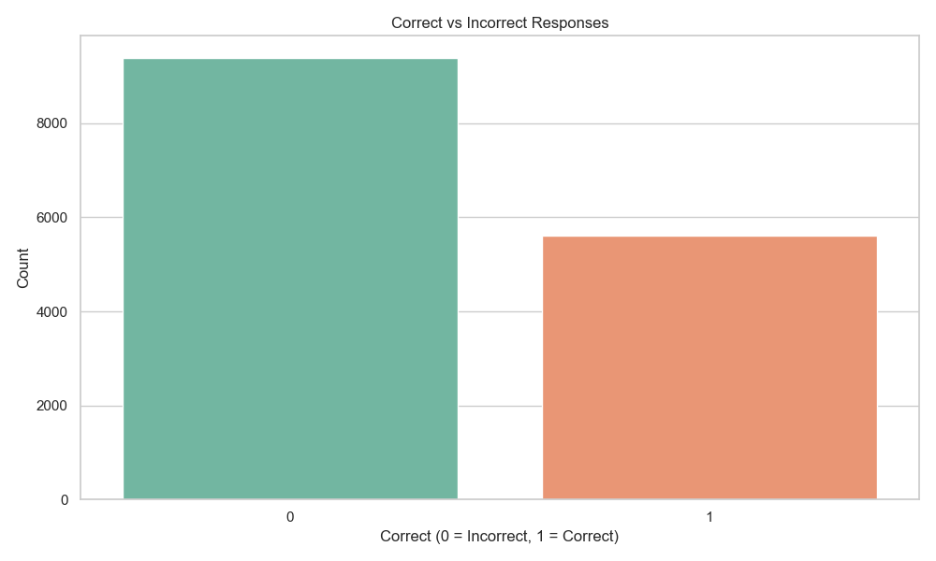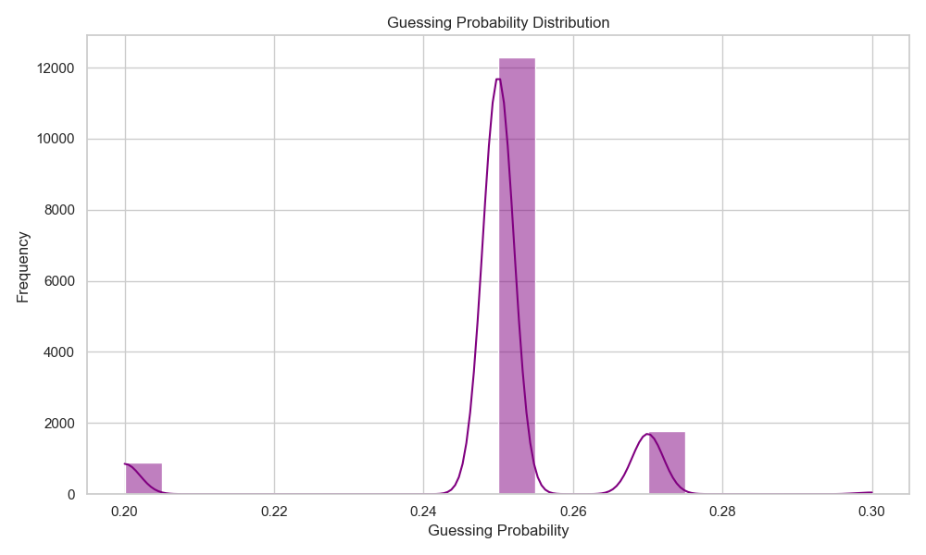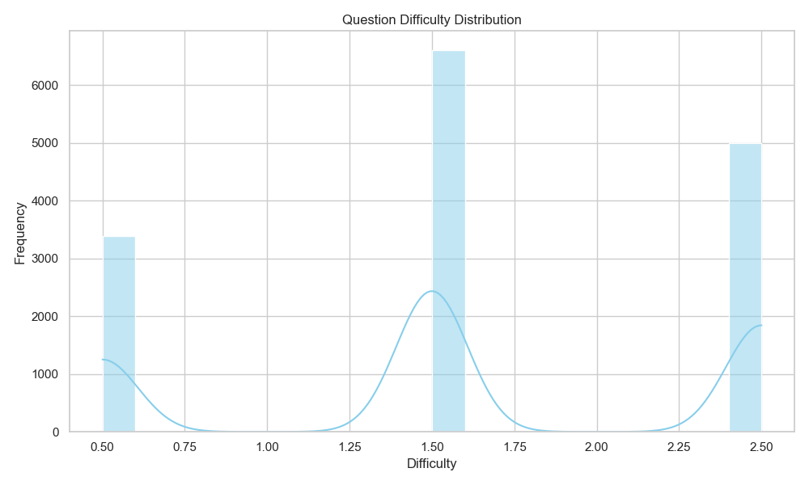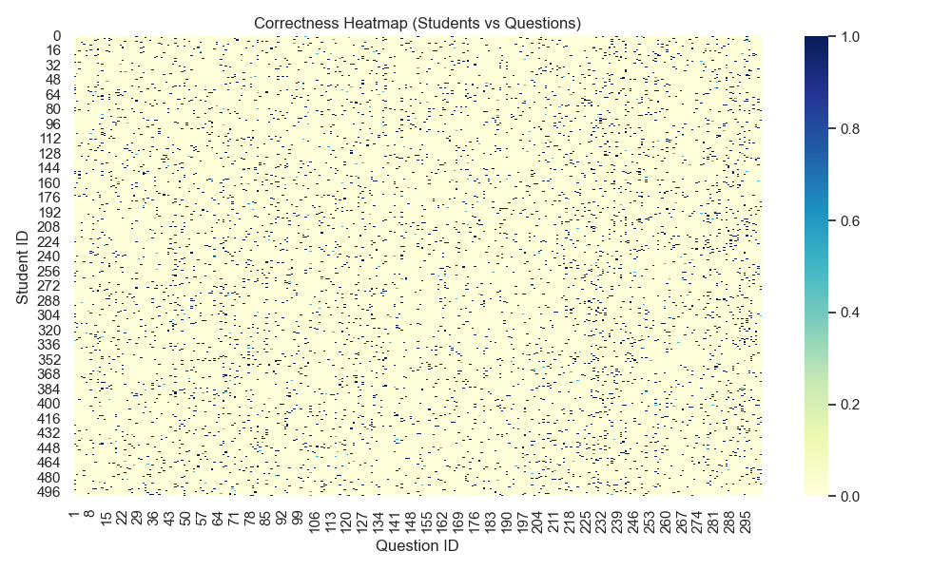

CHAPTER 5
SUMMARY, RECOMMENDATIONS, AND CONCLUSION

5.1. Summary
The idea behind this project was born out of the issues normally posed to learners in the field of programming education, particularly in the acquisition of the elementary concepts of data structures. Conventional evaluation tools make use of static tests that are not responsive to the learner’s skill level, hence giving questions either too hard or too simple, which prevents effective learning as well as motivation. The absence of interactive assessing conditions lowers learner motivation and usually results in the inadequate retention of the concepts in programming.
This project aimed to create a novel adaptive test system improving learners' knowledge of programming through the application of Computerized Adaptive Testing (CAT) founded on Item Response Theory (IRT) and gamification features. The overall purpose was to maximize test design for the concept of data structure to create personalized tests dynamically altering question difficulty according to learners' performance in real-time. This will create an effective learning path optimized for each student's requirements.
The study commenced with a thorough survey of adaptive testing methods and measurement models, and was next followed by the development of a CAT-IRT framework to estimate the ability of a learner and to choose questions in a way that maximizes accuracy. To mimic real educational conditions, a student interaction dataset was simulated, covering answers to different questions over a range of data structure topics, including linked lists, stacks, queues, trees, and graphs. This dataset served as a basis for model adaptation and evaluation.
Also, aspects of gamification were added to both the front-end and backend elements to further encourage increased user involvement. These include interactive user interfaces, tracking of progress, rewards in form of points and badges, and motivational loops to keep the learners motivated and to promote ongoing participation.
The system was extensively tested using standard performance metrics of Mean Reciprocal Rank (MRR), Normalized Discounted Cumulative Gain (nDCG), accuracy, and Root Mean Square Error (RMSE). The metrics showed that the CAT-IRT model is effective in accommodating various levels of learner abilities through the selection of questions having proper difficulty and discrimination values, thus increasing ability estimation accuracy. The gamified context further assisted by increasing the motivation and interaction time of learners.

5.2. Recommendations
On the basis of the results and noted limitations of this project, a number of suggestions can be made to strengthen and extend the system's functionality:
- Dataset Enlargement and Variety:
To enhance the precision and applicability of the CAT-IRT model further, larger and diversified datasets should be incorporated in the future. Adding coverage of a wider variety of programming themes with the inclusion of themes outside the domain of data structures, for instance, algorithms, design patterns, and software development processes, would allow the system to support broader curricula and learners.
- Mobile and Cross-Platform Compatibility:
Having a fully adaptive mobile version will enhance accessibility, enabling learners to take advantage of the adaptive test system at any time and from any place.
- Integration with Learning Management System (LMS):
Integrating the adaptive test platform with leading LMS platforms would enable straightforward deployment to educational institutions and the easier monitoring of learners' progress.
- Extension to Collaborative Learning Modes:
Looking into multi-user test modes in which learners are allowed to participate in peer challenges or group problem-solving would tap social learning advantages.

5.3. Conclusion
This final project successfully designed and developed a gamified Computerized Adaptive Testing system based on Item Response Theory to implement tests with the potential to advance learners' understanding of data structures. The system proved to possess the effective capability to customize tests dynamically choosing questions on the basis of the learners' respective abilities, thereby overcoming the shortcomings of conventional static tests.
The incorporation of gameplay elements across the platform increased learner motivation and engagement, making the assessment process both interactive and fun. Verifications with key metrics of MRR, nDCG, accuracy, and RMSE established that the CAT-IRT model offered valid and accurate ability estimation, while the gamification elements ensured that learner’s remain engaged.
This project pushes computational education forward by combining state-of-the-art psychometric design with motivational game design to enable personalized pathways of learning. Though further refinement of model accuracy and coverage of subject material may be forthcoming, the project provides a firm basis for ongoing development of intelligent, adaptable, and engaging assessment tools for computer programming.
Aside from its scholarly contribution, the system has considerable practical application in education, providing instructors with a scalable and data-driven approach to test and improve learners' comprehension at an efficient rate. This work underscores the possibility of using adaptive testing and gamified learning to revolutionize education assessment and enhance performance of students in computer science and allied disciplines.

REFERENCES
Boguslawski, S., Deer, R., & Dawson, M. G. (2024). Programming education and learner motivation in the age of generative AI: student and educator perspectives. Information and Learning Science. https://doi.org/10.1108/ILS-10-2023-0163
Chuang, T.-Y., Lu, Y.-H., Tsai, S.-R., & Chen, W. (2024). Examining Critical Thinking Skills in Game-Based Learning: A Behavioral Analysis Approach. https://doi.org/10.1109/iiai-aai63651.2024.00037
Gari, M. R. N., Walia, G., & Radermacher, A. (2018). Gamification in Computer Science Education: a Systematic Literature Review.
Hasan, M. N. (2024). Introduction to Data Structures Data Structures and Algorithms Course Code : CCE-2301. https://www.researchgate.net/publication/384707448_Introduction_to_Data_Structures_and_Algorithms
Hooshyar, D., Malva, L., Yang, Y., Pedaste, M., Wang, M., & Lim, H. (2020). An adaptive educational computer game: Effects on students’ knowledge and learning attitude in computational thinking. Computers in Human Behavior, 114, 106575. https://doi.org/10.1016/j.chb.2020.106575
Jaramillo-Mediavilla, L., Basantes-Andrade, A., Cabezas-González, M., & Casillas-Martín, S. (2024). Impact of Gamification on Motivation and Academic Performance: A Systematic Review. Education Sciences, 14(6), 639. https://doi.org/10.3390/educsci14060639
Karsen, M., Masrek, M. N., Uzir, N. A., & Safawi, A. R. (2022). Gamification in MOOC: A systematic literature review. Environment-Behaviour Proceedings Journal. https://doi.org/10.21834/ebpj.v7isi10.4111
Latu, E., & Chapman, E. (2002). Computerised adaptive testing. British Journal of Educational Technology, 33(5), 619–622. https://doi.org/10.1111/1467-8535.00296
Lavoué, E., Ju, Q., Hallifax, S., & Serna, A. (2021). Analyzing the relationships between learners’ motivation and observable engaged behaviors in a gamified learning environment. International Journal of Human-Computer Studies, 154, 102670. https://doi.org/10.1016/j.ijhcs.2021.102670
Learning and Gender Differences. Computers, 13(12). https://doi.org/10.3390/computers13120324
Li, C., Liang, L., Fryer, L. K., & Shum, A. (2024). The use of leaderboards in education: A systematic review of empirical evidence in higher education. Journal of Computer Assisted Learning. https://doi.org/10.1111/jcal.13077
Ma, H., Zeng, Y., Yang, S., Qin, C., Zhang, X., & Zhang, L. (2023). A novel computerized adaptive testing framework with decoupled learning selector. Complex and Intelligent Systems, 9(5), 5555–5566. https://doi.org/10.1007/s40747-023-01019-1
Ogunsakin, I. B., & Shogbesan, Y. (2018). Item Response Theory (IRT): A Modern Statistical Theory for Solving Measurement Problem in 21st Century. http://www.ijsre.com.
Oliveira, W., Hamari, J., Shi, L., Toda, A. M., Rodrigues, L., Palomino, P. T., & Isotani, S. (2022). Tailored gamification in education: A literature review and future agenda. Education and Information Technologies, 28(1), 373–406. https://doi.org/10.1007/s10639-022-11122-4
Rizzardini, R. H., Chan, M. M., & Guetl, C. (2016). An Attrition Model for MOOCs. In Elsevier eBooks. https://doi.org/10.1016/b978-0-12-803637-2.00014-2
Ružic, I. M., & Dumancic, M. (2015). Gamification in education. Informatologia, 48(3–4), 198–204. https://doi.org/10.3390/encyclopedia3040089
Triantafyllou, S. A., Sapounidis, T., & Farhaoui, Y. (2024). Gamification and Computational Thinking in Education: A systematic literature review. Salud, Ciencia y Tecnología. https://doi.org/10.56294/sctconf2024659
Troussas, C., Krouska, A., & Sgouropoulou, C. (2019). Collaboration and fuzzy-modeled personalization for mobile game-based learning in higher education. Computers & Education, 144, 103698. https://doi.org/10.1016/j.compedu.2019.103698
Wiredu, J. K., Abuba, N. S., & Acheampong, R. W. (2024). Enhancing Accessibility and Engagement in Computer Science Education for Diverse Learners. Asian Journal of Research in Computer Science. https://doi.org/10.9734/ajrcos/2024/v17i10509
Zhang, Z., & Huang, X. (2024). Exploring the impact of the adaptive gamified assessment on learners in blended learning. Education and Information Technologies. https://doi.org/10.1007/s10639-024-12708-w
Zourmpakis, A. I., Kalogiannakis, M., & Papadakis, S. (2024). The Effects of Adaptive Gamification in Science Learning: A Comparison Between Traditional Inquiry-Based

Concerto Platform. (2024). About the Concerto platform. The Psychometrics Centre, University of Cambridge. https://concertoplatform.com

